Benefits Claims Decision Support System (BCDSS)

System Design Document



**March 2016**

Version 1.0

Department of Veterans Affairs

Revision History

| Date | Version | Description | Author |
| --- | --- | --- | --- |
| 11/09/2015 | 0.1 | Document Creation | BCDSS Team |
| 12/15/2015 | 0.2 | Architecture updates | BCDSS Team |
| 1/15/2016 | 0.3 | Database and Logical Design Updates | BCDSS Team |
| 1/21/2016 | 0.4 | Context, Data, High-Level and Roles Updates | BCDSS Team |
| 1/26/2016 | 0.5 | Data Dictionary Added | BCDSS Team |
| 2/01/2016 | 0.6 | Architecture, Database, Security and Platform Design Updates | BCDSS Team |
| 2/05/2016 | 0.7 | Figures, Tables Added, RTM Inserted | BCDSS Team |
| 2/07/2016 | 0.8 | Document Cleaned and Labeled | BCDSS Team |
| 3/24/2016 | 0.9 | Architecture, Database and Design Updates | BCDSS Team |
| 3/28/2016 | 1.0 | Template updates | BCDSS Team |

.

Artifact Rationale

The System Design Document (SDD) is a dual-use document that provides the conceptual design as well as the as-built design. This document will be updated as the product is built, to reflect the as-built product.

Table of Contents

1. Introduction 1

1.1. Scope 1

1.2. User Profiles 1

2. Background 2

2.1. Overview of the System 2

2.2. Overview of the Business Process 2

2.3. Overview of the Significant Requirements 4

3. Conceptual Design 4

3.1. Conceptual Application Design 4

3.1.1. Ingest engine 4

3.1.2. Modeling engine 5

3.1.3. Models 5

3.1.4. Output Engine 5

3.1.5. Application Context 5

3.1.6. High-Level Application Design 7

3.1.6.1. BCDSS User Workflow 8

3.1.7. Application Locations 12

3.2. Conceptual Data Design 13

3.2.1. BCDSS Conceptual Data Model 13

3.2.1.1. Figure: BCDSS Conceptual Data Model 13

3.2.2. Database Information 14

3.2.2.1. Table: Database Inventory 14

3.2.3. User Interface Data Mapping - For Future Iteration: 15

3.2.3.1. Application Screen Interface 15

3.2.3.1.1. *<Insert name of screen>* 15

3.2.3.2. Application Report Interface 16

3.2.3.2.1. *<Insert name of report>* 16

3.2.3.3. Unmapped Data Element - For Future Iteration: 17

3.3. Conceptual Infrastructure Design 17

3.3.1. System Criticality and High Availability 17

3.3.2. Non-High Availability/Non-Production 18

3.3.3. Special Technology 19

3.3.4. Technology Locations 19

3.3.5. Conceptual Infrastructure Diagram 20

3.3.5.1. Location of Environments and External Interfaces 20

3.3.5.2. Conceptual Production String Diagram 22

4. System Architecture 22

4.1. Application Architecture 22

4.1.1.1. User Interface 23

4.1.1.2. Business Services 23

4.1.1.3. Technical Services 24

4.1.1.4. Data Services 24

4.1.1.5. External Interfaces 24

4.2. Hardware Architecture 24

4.2.1. Table: BCDSS Hardware Configuration 24

4.3. Software Architecture 25

4.3.1. Presentation Layer 26

4.3.2. Integration Layer 26

4.3.3. Application Layer 26

4.3.3.1. User Validation 26

4.3.3.2. Figure: BCDSS Model Agent Role 27

4.3.3.3. Figure: BCDSS Modeler Role 27

4.3.3.4. Figure: BCDSS Administrator Role 27

4.3.3.5. Figure: BCDSS Role-based Access Control 28

4.3.4. Inbound Data Service 29

4.3.5. Modeling Engine 29

4.3.6. Admin Services 29

4.3.6.1. Logging and Audit trail 29

4.3.6.2. Exception Handling 29

4.3.7. Reporting 29

4.3.8. Persistance Layer 29

4.4. Network Architecture 30

4.5. Service Oriented Architecture / ESS 30

4.6. Enterprise Architecture 30

4.6.1. Application Implementation 31

4.6.2. Continuous Integration (CI) Process 31

4.6.3. BCDSS Build and Deployment process 32

5. Data Design 32

5.1. DBMS Files 32

5.2. Non-DBMS Files 33

5.3. Data View 33

5.3.1. BCDSS Role Based Access Control 34

5.3.2. BCDSS Data Ingest and Processing 34

5.3.3. BCDSS Predictive Model Meta Data 35

5.3.4. The BCDSS CDM Data Dictionary – *Additions in Future Iteration* 36

6. Detailed Design 37

6.1. Hardware Detailed Design 37

6.2. Software Detailed Design 37

6.2.1. Conceptual Design 37

6.2.1.1. Product Perspective 38

6.2.1.1.1. User Interfaces 38

6.2.1.1.2. Hardware Interfaces 38

6.2.1.1.3. Software Interfaces 38

6.2.1.1.4. Communications Interfaces 38

6.2.1.1.5. Memory Constraints 39

6.2.1.1.6. Special Operations 39

6.2.1.2. Product Features 39

6.2.1.3. User Characteristics 39

6.2.1.4. Dependencies and Constraints 39

6.2.2. Specific Requirements 40

6.2.2.1. Database Repository 40

6.2.2.2. System Features 41

6.2.2.3. Design Element Tables 41

6.2.2.3.1. Routines (Entry Points) 41

6.2.2.3.2. Templates 43

6.2.2.3.3. Bulletins 44

6.2.2.3.4. Data Entries Affected by the Design 45

6.2.2.3.5. Unique Record(s) 45

6.2.2.3.6. File or Global Size Changes 45

6.2.2.3.7. Mail Groups 46

6.2.2.3.8. Security Keys 47

6.2.2.3.9. Options 49

6.2.2.3.10. Protocols 50

6.2.2.3.11. Remote Procedure Call (RPC) 52

6.2.2.3.12. Constants Defined in Interface 52

6.2.2.3.13. Variables Defined in Interface 53

6.2.2.3.14. Types Defined in Interface 53

6.2.2.3.15. GUI 53

6.2.2.3.16. GUI Classes 53

6.2.2.3.17. Current Form 54

6.2.2.3.18. Modified Form 54

6.2.2.3.19. Components on Form 54

6.2.2.3.20. Events 54

6.2.2.3.21. Methods 54

6.2.2.3.22. Special References 54

6.2.2.3.23. Class Events 54

6.2.2.3.24. Class Methods 54

6.2.2.3.25. Class Properties 55

6.2.2.3.26. Uses Clause 55

6.2.2.3.27. Forms 55

6.2.2.3.28. Functions 56

6.2.2.3.29. Dialog 57

6.2.2.3.30. Help Frame 58

6.2.2.3.31. HL7 Application Parameter 59

6.2.2.3.32. HL7 Logical Link 60

6.2.2.3.33. COTS Interface 60

6.3. Network Detailed Design 61

6.4. Security and Privacy 61

6.4.1. Security 61

6.4.2. Privacy 62

6.5. Service Oriented Architecture / ESS Detailed Design 63

6.5.1. Service Description for <Consumed Service Name> 63

6.5.2. Service Design for <Provided Service Name> 63

6.5.2.1. Introduction 63

6.5.2.1.1. Purpose and Scope of Service 63

6.5.2.1.2. Links to Other Documents 63

6.5.2.2. Service Details 64

6.5.2.2.1. Service Identification 64

6.5.2.2.2. Service Versions 65

6.5.2.2.3. Summary of Design and Platform Details 65

6.5.2.2.3.1. SOA Pattern(s) Implemented 65

6.5.2.2.3.2. COTS Platform vendor names and versions for hosting platform 65

6.5.2.3. Dependencies 65

6.5.2.4. Service Design Details 65

6.5.2.4.1. Interface Technical Specs 65

6.5.2.4.1.1. Service Invocation Type 66

6.5.2.4.1.2. Service Interface Type 66

6.5.2.4.1.3. Service Name 66

6.5.2.4.1.4. Interface 66

6.5.2.4.1.5. End Points 66

6.5.2.4.1.6. Operations or Methods 66

6.5.2.4.1.7. Message Schemas 66

6.5.2.4.2. Information Model 67

6.5.2.4.2.1. Class Diagram and Description of Entities Involved 67

6.5.2.4.2.2. Mappings from ELDM to Standards Based Schemas 67

6.5.2.4.3. Behavior Model (AKA Use Case Realization) 67

6.5.2.4.3.1. Use Cases (Use Case Model) 67

6.5.2.4.3.2. Interaction Diagrams 67

6.5.2.5. Gap Analysis 67

6.5.2.5.1. Variances from Enterprise Target Architecture 68

6.5.2.5.2. Variances from SLDs 68

6.5.2.5.3. Variances from Standards and Policies 68

6.5.2.5.4. Justification for Exceptions and Mitigation 68

7. External System Interface Design 68

7.1. Interface Architecture 68

7.2. Interface Detailed Design 69

8. Human-Machine Interface 70

8.1. Interface Design Rules 70

8.2. Inputs 70

8.3. Outputs 70

8.4. Navigation Hierarchy 71

8.4.1. Screen [x.1] 71

8.4.2. Screen [x.2] 71

8.4.3. Screen [x.3] 71

9. Attachment A – Approval Signatures 71

A. Additional Information 72

A.1. Identification of Technology and Standards 72

A.1.1 *For Future Iteration:* 72

A.2. Constraining Policies, Directives and Procedures 72

A.1.2 *For Future Iteration:* 72

A.3. Requirements Traceability Matrix 72

A.1.3 BCDSS RTM 72

A.4. Packaging and Installation 72

A.1.4 *For Future Iteration:* 72

A.5. Design Metrics 72

A.1.5 *For Future Iteration:* 72

# Introduction

The System Design Document describes the Benefits Claims Decision Support System (BCDSS) system requirements, operating environment, system architecture, database design, input formats, output formats, detailed design, processing logic, and external interfaces.

## Scope

In 2013, Compensation Service initiated a research effort to determine the feasibility of using predictive models to automate disability claims processing and focused on requests for increase claims. This research developed predictive models to forecast disability ratings based on the type of claim, Veteran characteristics, military service, demographic data, previous claims history and ratings, and other key parameters.

The research to date has been focused on producing predictive models for rating disability claims for the hearing and knee body systems which represent the highest frequency of disabilities claimed. VBA seeks to create a software platform to implement predictive models to rate historical disability claims.

[Click here](https://bcdssteam.atlassian.net/wiki/download/attachments/7831557/BCDSS_RTM_MARCH.03_Update.xlsx?api=v2) for latest requirement traceiability matrix.

## User Profiles

The BCDSS application’s global navigation menu allows the user to navigate to all functional areas of the application. Three user roles/ levels are provided with tab-based navigation that allows the user to enter the rating details in the order. The application is designed to meet the needs of the various user types such as Model Agent, Modeler and Administrator.

The below table decribes user roles and description

|  |  |
| --- | --- |
| Inferred Role | Summary |
| Model Agent | * Identifies what models should be “ingested” into the system * Executes routine that verifies that a new model conforms to system specifications * Makes controlled edits to existing models within the system |
| Modeler | * Selects – from those available within the system – the target set of claims data to which models will be applied * Selects - from those available within the system – where and in what format modeling results will be output * Applies the models under the control of the system |
| Administrator | * Authorizes – from profiles available within the system - user access and privaleges * Defines where and in what format, new models are readied for conformance testing and ingest * Defines what target claims data are available for modeling * Defines what formats and destinations are available for modeling results |

# Background

## Overview of the System

The mission of the Department of Veterans Affairs (VA) is to provide a seamless experience of benefits and services to Veterans of the United States. The VA’s Veterans Benefits Administration (VBA) is undergoing transformation to significantly modernize and improve the delivery of benefits to the nation’s Veterans. In meeting these goals, the VA seeks to utilize advanced data science techniques to enhance service delivery and integrate these techniques into the existing service delivery and underlying technology application and data infrastructure. To drive the success of transformation objectives, the VA, in partnership with industry, must provide extensive strategic, technical, and program management direction to guide all transformation activities. That direction must be supported by advanced technology and data science expertise.

Pro-sphere Tek (PST) shall design, develop, test and demonstrate an integrated data analytics and modeling system, called the Benefits Claims Decision Support System (BCDSS). We will develop 2 predictive models (for Ear and Knee disability conditions) with parameters to support a repository and platform design. As explained by the government, development and design of these models is contingent on the VA’s key data based on historical claims for use with the BCDSS and with the VA provided guidance from results in the Veterans Administration Disability Rating Engineering Notebooks.

## Overview of the Business Process

The BCDSS solution applies predictive models stored within a managed library to claims, with related historical claimant data to produce issue-specific Combined Disability Determinations (CDDs) for supplemental claims for increases. If BCDSS proves operationally viable and beneficial, production capabilities could be integrated within VBA’s claims adjudication process authorized personnel to apply the calculated ratings consistent with corresponding policy, guidance, and appropriate circumstances.

The BCDS application platform is responsible for ingest of VA historical claims data and current claim for application of predictive model for automated claim adjudication and rating. The below diagram illustrates the approach for deriving the ear and knee model can storage of these two models in the BCDS application platform data repository. The BCDS platform executes these models against claims to produce a report for user analysis of model results.



The BCDSS solution is based on the guidelines provided by the VA and assumes the following unless corrected:

* The current "working design concept" places greater emphasis on ingest, creating a set of predictive characteristics of the claim. By using calculations and text extraction functions, and then comparing that to a two dimensional array, to arrive at a predicted rating value (or CDD) for the modeled condition. The expectation that the developer of any NEW models would provide the specific predictive features, the populated two dimensional array (for this set of values for each feature, the following predicted rating is the result), and the calculations needed to produce the features. This construction is scalable and should perform well at operational throughput.
* The current “working design concept” draws on information about the "target claim" (the claim that is to be auto-adjudicated,) and prior decision data for the related claimant (the Veteran who filed the target claim, or his dependent, etc.).
* The current "working design concept" draws on decision data (CDD for the EAR, CDD over all, etc.) immediately preceding the target claim, to calculate key predictive claim characteristics. As a result, the computational capabilities needed are basic. The design does not currently envision including computation capabilities (like machine learning algorithms, etc.) that would gather data similar about claims or claimants similar to that of the target claim. Then apply sophisticated computations to derive a result (or results). This would be necessary to auto-adjudicate more complex "original claims" in real-time, during implementation.

## Overview of the Significant Requirements

The BCDSS solution applies predictive models stored within a managed library to claims, with information (e.g., claim and claimant-specific information), store it for comparative analysis, apply necessary formatting, and output the results in accordance with user specifications.related historical claimant data to produce issue-specific Combined Disability Determinations (CDDs) for supplemental claims for increases.

[Click here](https://bcdssteam.atlassian.net/wiki/download/attachments/7831557/BCDSS_RTM_MARCH.03_Update.xlsx?api=v2) for latest requirement traceiability matrix.

# Conceptual Design

## Conceptual Application Design

.

A summary of the Platform broken down into various components:

### Ingest engine

The BCDSS platform will execute the modeling rules against the target claim and related claims data to create the modeling composite for the target claim.

### Modeling engine

The modeling engine will compare modeling composite for the target claim to the predictive decision matrix, and identify whether there is a match

* + When there IS NOT a match, the model will be identified as “inapplicable” to the claim for the subject body system or group of issues
  + When there IS a match, the model will assign the corresponding disability determination (or rating).

### Models

BCDSS models will be composed of two key components

* + A suite of rules or computations that extract, format, or calculate predictive characteristics or “features”
  + A predictive decision matrix or array composed of an inventory of scenarios (rows in the matrix), each of which containing a suite of predictive features and a corresponding rating determination

### Output Engine

The Output engine will combine the modeling results, with necessary reference.

### Application Context

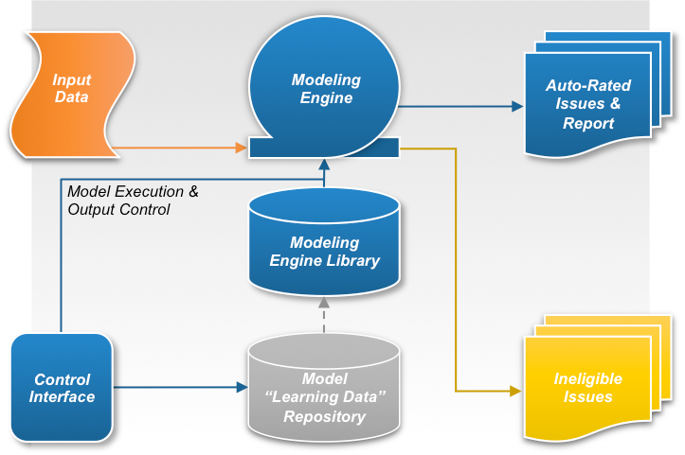

The above BCDSS application context diagram depicted in the figure below (Figure 1) is composed of several primary components:

Table 5 (Grouping): Application Context Description

Object

| ID | Name | Description | Interface Name | Interface System |
| --- | --- | --- | --- | --- |
|  |  |  |  |  |
|  | Predictive Model “Model Formulation Data” Repository | This component stores statistically relevant enterprise data supporting current and future predictive models. These data will be used to formulate, validate, and refine current and future predictive models. |  |  |
|  | Predictive Model Library | This component stores the established predictive models for use by the modeling engine to automatically determine ratings for issues contained within relevant claimant data sets. |  |  |
|  | Modeling Rules Engine | This component provides the platform and modeling logic for ingesting claimant data sets, determining whether the predictive models can be applied, applying the predictive models, and outputting either auto-rated issues and the related report for the claimant data set, or the ineligible issues for the claimant data set. |  |  |
|  | Control Interface | This component allows authorized users to control how the data ingest and auto-adjudication system operates, provides means to control the format and content of the output, and provides the mechanism to control the predictive model library and refinement of the underlying data. |  |  |

Interfaces External to OI&T

| ID | Name | Related Object | Input Messages | Output Messages | External Party |
| --- | --- | --- | --- | --- | --- |
| < ID from diagram> | <Interface name from the object rows above> | <Object from the list above that is the source of this interface> | <For each input message, enter a business description of the data being input> | <For each output message, enter a business description of the data being output> | <Name of external party> |

Interfaces Internal to OI&T

| ID | Name | Related Object | Input Messages | Output Messages | External Party |
| --- | --- | --- | --- | --- | --- |
| < ID from diagram> | <Interface name from the object rows above> | <Object from the list above that is the source of this interface> | <For each input message, enter a business description of the data being input> | <For each output message, enter a business description of the data being output> | <Name of external party> |

Externally Shared Data Stores

| ID | Name | Data Stored | Owner | Access |
| --- | --- | --- | --- | --- |
| < ID from diagram> | <Name of the data store> | <Description of the data being stored> | <This System / Name of OIT or external organization> | <Enter the Create, Read, Update, or Delete (CRUD) operations that this system does on this data store> |

### High-Level Application Design

The BCDSS application platform is responsible for ingest of VA historical claims data and current claim for application of predictive model for automated claim adjudication and rating. The above diagram illustrates the approach for deriving the ear and knee model can storage of these two models in the BCDS application platform data repository. The BCDSS platform executes these models against claims to produce a report for user analysis of model results.



#### BCDSS User Workflow

The below diagram explains application user workflow process.



The High-Level Application Design identifies the major components of the application and the relationships of the major application components to each other and to the surrounding applications. The major components of the application are at the subsystem or top-level service area. Many different graphical formats are acceptable for the High-Level Application Design Diagram. Lower-level services will be defined and documented in the Logical Application Design section.

**Error! Reference source not found.** illustrates a High-Level Application Design in the form of a dataflow diagram. This diagram differs from the diagram in Figure 2 in that the single object representing this system in Figure 2 is decomposed into its major components. Use

Table 6 to describe the objects in **Error! Reference source not found.**.

Note: If an extension to a legacy system is being developed without use of services, all references to “Service” should be changed to “Subsystem.”

A Collaboration Diagram, or in the case of Services, a Service Capability Diagram may be included instead or an Application Diagram if it illustrates the subject better.



Sample High-Level Application Design

Sample High-Level Application Design

Figure : Sample High-Level Application Design

Table 6: Objects in the High Level Application Design

Objects / Components to be Built or Modified

| ID | Name | Description | Service or Legacy Code | External Interface Name | External Interface ID | Internal Interface Name | Internal Interface ID | SDP Sections 1&2 |
| --- | --- | --- | --- | --- | --- | --- | --- | --- |
| < ID from diagram> | <Name of high level service or internal subsystems> | <Business level discussion of the function or role of the service or subsystem> | <Service / modification to legacy system> | <Name of each of the external interfaces to this object> | <ID of each of the external interfaces to this object> | <Name of each of the internal interfaces to this object> | <ID of each of the internal interfaces to this object> | [Approved / Submitted / Being Developed] |

Internal Data Stores

| ID | Name | Data Stored | Steward | Access |
| --- | --- | --- | --- | --- |
| < ID from diagram> | <Name of the data store> | <Description of the data being stored> | <Name of the system/subsystem /service that is the steward for the data> | <Which CRUD operations does this system do on this data store> |

### Application Locations

Use Table 7 to specify the locations at which the application components will be hosted.

Consideration should be given to adopt cloud technologies as potential solutions. Leveraging cloud technologies is part of a larger effort by the Office of Management and Budget (OMB) to reform Federal IT Management. Considerations such as regional deployments etc. should be documented in this section.

Table 7: Application Locations

| Application Component | Description | Location at Which Component is Run | Type |
| --- | --- | --- | --- |
| <Component name> | <Description> | <Facility name> | <Presentation Logic/Business Logic/Data Logic/Interface Code> |

Table 8: Application Users

| Application Component | Location | User |
| --- | --- | --- |
| <Component name> | <Facility name> | <Role> |

## Conceptual Data Design

### BCDSS Conceptual Data Model

The conceptual data model (CDM) above shows the high level business entities that will be ingested, processed and produced by the BCDSS application platform.

#### Figure: BCDSS Conceptual Data Model

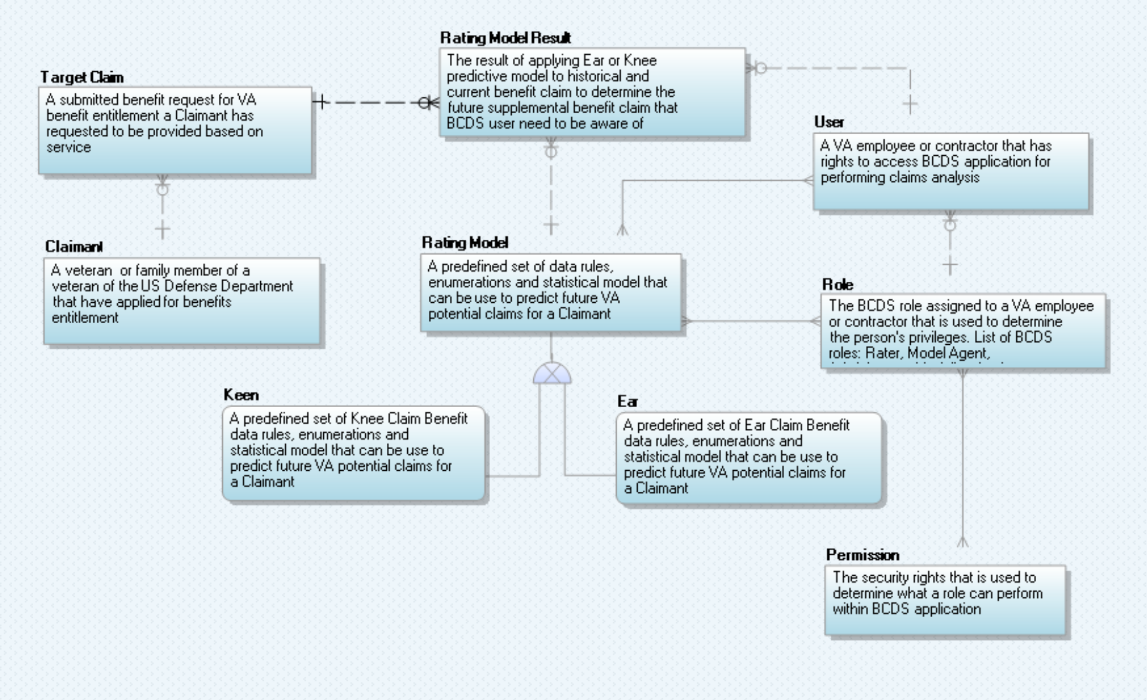

### Database Information

#### Table: Database Inventory

| Database Name | Description | Type | Steward |
| --- | --- | --- | --- |
| Model Repository | A data repository responsible for persisting Ear & Knee predictive models and the associated data for operation of BCDS Application | Relational Database Management System (RDBMS) - Oracle | TBD |
| Reporting Repository | A data repository responsible for persisting the results of the predictive model and ratings determination for reporting and analysis purpose | Relational Database Management System (RDBMS) - Oracle | TBD |
| Staging Repository | A data repository responsible for staging of data and preparation of data and predictive models before processing | Relational Database Management System (RDBMS) - Oracle | TBD |

A project conceptual data model (CDM) is a high-level representation of the data entities and their relationships. It does not normally include the data elements that comprise each entity. It is a first step toward developing the more detailed logical data model (LDM) that will be provided during the Logical Data Design.

Figure 3 illustrates a sample of a project CDM.

Figure : Sample Project Conceptual Data Mode

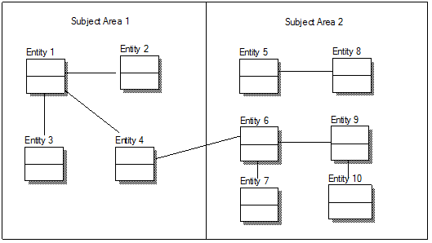

### User Interface Data Mapping - For Future Iteration:

BCDSS Application user interface (UI) in the application presentation layer will be available for user to enter data into the system. Direct user access to the data repositories of BCDS will not be available.

This section describes and defines the format and information that will be available for users of the product to be able to enter data into the database or to retrieve information from the database, if applicable.

#### Application Screen Interface

Create a new subsection for each screen of the Graphical User Interface (GUI) that users will have access to, in order to enter or update information in the database.)

##### *<Insert name of screen>*

Figure 4: <screen name> Screen represents the screen that <describes what the screen accomplishes>; Table 10 describes it. Paste a screenshot below and complete the table to describe the screen.

Figure : *<screen name>* Screen

Table 10: *<screen name>* Screen Description

| Graphical User Interface (GUI) Field | Table (Database Table that field connects to) | Field (Field in Table that the GUI field connects to) | Comments |
| --- | --- | --- | --- |
| <Name> | <xxx> | <PATIENT_ NAME> | <Add any comments or descriptive information that would be relevant to the tester> |
| <SSN> | <xxx> | <SSN> |  |
| Date of Birth (Age) | <yyyy> | DATE_OF_BIRTH DATE_OF_DEATH (if deceased) |  |

#### Application Report Interface

No Reporting capability currently planned as part of the current pilot scope.

##### *<Insert name of report>*

<Create a new subsection for each report> Figure 6 represent <name> screen and Table 16 describes it…

Figure 5 represents the <report name>; Table 11 describes it. Paste a screenshot of the report below and complete the table to describe the report.

Figure : *< Report name>* Report

Table 11: *<Report name>* Description

| Report Column | Data Source *<Table Name. Fieldname>* |
| --- | --- |
| Patient | <xxx.PATIENT_NAME> |
| SSN | <xxx.SSN> |
| DoB | <yyyy.DATE_OF_BIRTH> |

#### Unmapped Data Element - For Future Iteration:

In this section describe any database element that was not mapped to a screen and the reason the data element(s) was not mapped. This section may be skipped if there is no User Interface involved in the project, such a building a service offering etc.

## Conceptual Infrastructure Design

The BCDSS application environment is deployed in two configurations: High Availability(HA) and Non-High Availability(Non-HA). The Production environment and prod-like environments are built as a High-Availability environment; while the majority of the non-production environments (i.e. Development, Testing, SQA, UAT) do not require the same availability and are built with less resilience and fail-over capability.

### System Criticality and High Availability

The infrastructure architecture includes the appropriate deployment and configuration of firewalls to define network segments. We place web servers in a Demilitarized Zone (DMZ) so that end-users can easily access these resources to conduct their business. The DMZ is protected from the Internet by a set of edge firewalls. Assets storing data are placed deeper in the network on an internal segment that is protected from the DMZ from an additional set of firewalls.

Highly critical assets may be placed even deeper in the network in a highly secure network segment that is separated by yet more firewall. Our solution employs secure data transmission protocols, including the secure sockets layer (SSL) protocol and public key authentication, signing and encryption.

The following figure describes the production high availability environment. This design is also used for select non-production environments that require the same configuration as production for testing purposes.



In the diagram above, in the event of a system failure, or when a technology component or network becomes unavailable, the solution employs continuity of interface operations through high-availability and redundant databases and devices. The HA solution provides automated forwarding and manual options to reconfigure devices and quickly switch from backup to primary, or passive to active. These features offer continuity of operations for our interfaces in the event of a local outage, loss of component availability, or system failure.

The BCDSS application is going to deploy on tomcat server. Using tomcat clustering capabilities these applications can be spread across multiple JVM process instances. Tomcat supports clusters of server processes, with transparent load balancing and failover support among the processes. This gives the solution inherent high-availability support. Moreover, cluster instances need not be deployed in the same machines or even the same physical data-center. Tomcat applications typically provide linear scalability; moreover, it is very simple to add additional machines or Tomcat server processes – even within a running production system.

### Non-High Availability/Non-Production

BCDS application platform is a three (3) teir application architecture. The below diagram shows, web tier, application and database tiers for non-production use such as Development and Test environments.



### Special Technology

If any special technology was identified in Section 2.5.9 as part of this system, describe the device and the type of location at which it will be installed. This information may be provided using Table 12.

Table 12: Special Technology Requirements

| Special Technology | Description | Notional Location | TRM Status |
| --- | --- | --- | --- |
| <Name> | <Business language description> | <At what type of location will this technology be deployed?> | <Is this technology in the TRM?  (Yes / No)> |

### Technology Locations

This section describes the various technology components that will be used. If known, provide the name of the datacenter at which the technology will be installed. If not, specify as Site A, Site B etc. Provide this information in Table 13.

Table 13: Technology Location Details

| Technology Component  Production 1 | Location | Usage |
| --- | --- | --- |
| Workstations |  |  |
| Special Hardware |  |  |
| Interface Processors |  |  |
| Legacy Mainframe |  |  |
| Legacy Application Server |  |  |
| Legacy Databases |  |  |
| Other |  |  |

| Technology Component  Production 2 | Location | Usage |
| --- | --- | --- |
| <copy from Prod 1 set, or enter new ones as appropriate> |  |  |

| Technology Component  Certification | Location | Usage |
| --- | --- | --- |
|  |  |  |

| Technology Component  Education | Location | Usage |
| --- | --- | --- |
|  |  |  |

| Technology Component  Test | Location | Usage |
| --- | --- | --- |
|  |  |  |

| Technology Component  Development | Location | Usage |
| --- | --- | --- |
|  |  |  |

### Conceptual Infrastructure Diagram

#### Location of Environments and External Interfaces

Create a diagram to show the environments that will be supported. As illustrated in

Figure 6, the diagram should show the following:

* Local networks to which they will be attached (Production, Test, or Development)
* Locations at which they will be installed
* External connections (each external interface should be shown in terms of where it enters the network).



Sample Conceptual Networks and Environments

Sample Conceptual Networks and Environments

Figure : Sample Conceptual Networks and Environments

#### Conceptual Production String Diagram

Create a diagram to show the configuration of a single production string.

Additional components, such as the mainframe, other Web servers, or other major components should be included if they are expected to be required.

Figure : Conceptual Production String Diagram

# System Architecture

The below diagram describes System Architecture along with the various system components that will be used in architecting the BCDSS solution.



The below interaction of software components along with its responsibilities,

* Web server is responsible for serving web pages via the HTTP(s) protocol to clients. The webserver sends out web pages in response to requests from browsers. A page request is generated when users cliecks on a link or a button on a web page.
* A firewall is a network security system that monitors and controls the incoming and outgoing network traffic based on predetermined security rules.
* Application server hosts BCDSS application and hosts the business logic of the application. It serves requests for dynamic web pages from webserver.
* Oracle Database stores models, processed claimant ratings data, role based user security and audit trails of the application in a relational format.

## Application Architecture

The application architecture descibes how the various components of the BCDSS Solution are integrated with each other to build an integrated application. The BCDSS is multi-tiered, modular, and rules-engine based application. It is based on the principles of Service Oriented Architecture (SOA), and employs open standards for interfaces making it configurable to meet VBA requirements.



In the diagram above, service components are built for interoperability. Services adhere to the Web Services Interoperability (WS-I) standard and are based on the Service Contract Specification. Services within this layer are classified into the following categories.

#### User Interface

The user interface Layer provides graphical user interfaces to human and system users to access services through various access channels.

The presentation layer for BCDSS web-based application use services provided by the business services to facilitate the interaction of the Modeling engine, reporting engine and portal applications. The BCDSS presentation architecture is based on the event driven application architecture deployed within the tomcat container.

#### Business Services

Business Services encapsulate the application and business logic that supports BCDSS business functions. Services within this layer are invoked in various methods. Trusted application components and services in other architecture layers may invoke services directly via open Java EE-compliant application interfaces (APIs). This method of invocation is often preferred for performance reasons when both the consumer and provider are known and within trusted zones; are both contained within the BCDSS system boundary; or exist within the same Java container.

Rules Services within solution provide the encapsulation and isolation of business rules logic for implementing policy and complex rules. Business Rules are authored in a consistent, technology-neutral and human-readable format and translated into machine-executable format by the BCDS rule authoring tool.

#### Technical Services

Technical services include common architecture services (such as batch management, auditing, and exception handling) and those services used by applications to access the core set of functionality provided by other software that are plugged into the BCDSS framework; including business rules management and reporting functionalities.

#### Data Services

Data Services provide the application access to shared data. The Data Services components are written in Java and use open standards and specifications. The Data Services are coded to the Java Persistence API (JPA), a data management framework, and employ object to relational mapping techniques to access data within the underlying Database Management System (DBMS).

#### External Interfaces

The solution’s first implementation is for Prototype within the VA’s Sandbox environment. If requested it can be updated to be used to connect, mediate and manage messaging between heterogeneous services, legacy systems, and other integration instances across the enterprise.

## Hardware Architecture

The BCDSS project team is going to work with VBA team to select hardware configurations that will meet VBA performance and scalability requirements. This includes utilization of pre-configured hardware, such as Solaris/Linux servers, supporting application needs. The hardware configurations should have the capability to significantly scale to meet future needs. Use of virtualization reduces the costs by lowering processor counts and associated processor-count based software licenses.

### Table: BCDSS Hardware Configuration

|  |  |  |  |  |  |
| --- | --- | --- | --- | --- | --- |
| Hardware Item # | Hardware Item | Environment | Description | Operating System | Count |
| 1 | Load balancers | Production | Apache HTTP server 8GB RAM and 100 GB Storage | Linux | 2 |
| 2 | DR Router | Production | Cisco | N/A | 1 |
| 3 | DR Firewalls | Production | Cisco | N/A | 2 |
| 4 | DR Switch | Production | Cisco | N/A | 1 |
| 5 | Application Servers | Production | Tomcat and Reports server 16 GB RAM and 1TB Storage | Linux/Solaris | 4 |

## Software Architecture

The BCDSS enterprise web application is a lightweight, browser based application that doesn’t require installation of other software on the user's desktop. The figure below depicts our proposed approach provides a clean separation between the presentation layer, and application services layer, which allows VBA to maximize flexibility and reduce the costs associated with maintaining the BCDS system infrastructure.. The web application is browser-independent and is designed to operate on Internet Explorer 11, with only minimal hardware related requirements.

The BCDSS Web application makes HTTP/HTTPS calls to to VBMS System for inbound claims data using SOAP webservices. The application implements standard provider security practices to consume a service.

The below diagram explains BCDSS application software architecture.



### Presentation Layer

The BCDS web applications incorporate usability features for individuals with disabilities and provide the BCDS system with ADA compliance. Additionally, the application supports multiple modalities for consumers when interacting with the BCDS system, including support for browsers that work on mobile platforms.

The front-end technologies used for BCDS web application development are HTML 5, Angular JS and CSS. AngularJS is a structural framework for dynamic web apps. It handles all of the DOM and AJAX code and puts it in a well-defined structure.

### Integration Layer

The most basic interaction in Service Oriented Architeccture (SOA) is between service providers and consumers. The two parties must come to an agreement or contract that specifies the details of the service the provider is performing. The contract loosely couples the relationship between provider and consumer. The mock services are being used for static request and resonse processing which is useful for developers to test their client code without invoking the real webservice.

### Application Layer

#### User Validation

The BCDS application’s global navigation menu allows the user to navigate to all functional areas of the application. Three user roles/ levels are provided with tab-based navigation that allows the user to enter the rating details in the order. The application is designed to meet the needs of the various user types such as Model Agent, Modeler and Administrator as depicted below.

The application allows the three user levels/ roles depicted individually below to edit field data if they have the appropriate user access levels. Fields that a user does not have access rights for are not viewable by the user. The user/ role only sees those fields they can access based upon role based security functionality provided by the BCDS system. Security is added to the application to prevent users from editing certain data, based on data type and user type.

#### Figure: BCDSS Model Agent Role

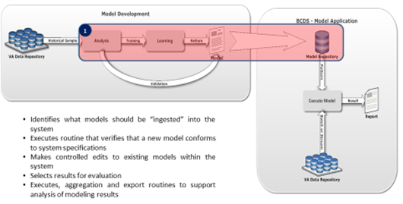

#### Figure: BCDSS Modeler Role

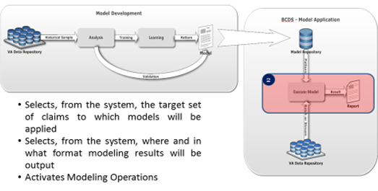

#### Figure: BCDSS Administrator Role

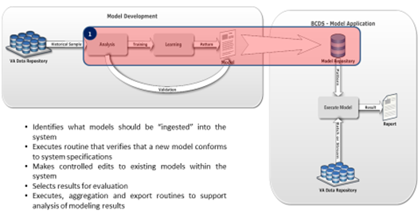

Access roles, rules, permissions, and groups are configurable in the BCDS administration module. The solution has granular capabilities to define roles, permissions, groups, and rules. These capabilities are restricted to selected administrators only.

#### Figure: BCDSS Role-based Access Control

The ER diagram below depicts what will be used to support the role based access control (RBAC) capabilities required by BCDS application platform. It provides the flexibility to define security (user access) from screen level of the application of application widget level that enables a “fine grain access” to the platform features

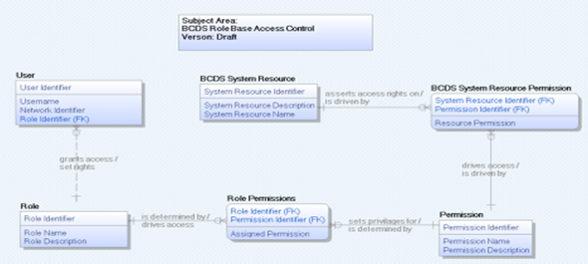

### Inbound Data Service

The BCDS application is going to get target calims and claimant data from VMBS centralized system using a synchronized webservice call. The application consumes an existing webservice developed by one of the VBMS applications to process claims data on-demand basis.

### Modeling Engine

The BCDS modeling engine is a real-time, accurate rating determinations are supported by a modern, flexible Business Rules Engine where non-technical users can participate in the rules creation and maintenance process and that can be provided as a shared service for use by other programs.

By centralizing rules within Modeling engine and sharing rules across BCDS system, VBA can eliminate having to maintain business rules in multiple systems.

### Admin Services

#### Logging and Audit trail

The BCDS application includes a robust audit trail, tracking user transactions to identify who initiates each action. It captures the ID of the person who made the change, the time and date of the change, the network location/IP address of the person, the new and previous values, and the outcome, if any, of the event. This data is accessible by authorized users for reporting and Quality Assurance processes.

#### Exception Handling

The user is provided with on-screen validations when invalid entries are made. Error messages presented to the user are clear and expressed in nontechnical terms, providing the user with the information needed to resolve errors and complete a successful interaction with the system. One example is that if a required field on a page is not completed, a user is warned that the data is missing and is provided a link to that particular field.

### Reporting

The BCDS reporting engine is a server-based reporting dashboard that offers useful features including matrices, ad hoc reports, custom report items and a variety of presentation formats such as PDF and CSV.

Types of reports include:

* Required standard reports.
* Reporting histories for trending and monitoring of operational performance.

### Persistance Layer

Business logic components executes SQLs using JPA-Hibernate framework to read/write data from database.

## Network Architecture

The BCDS application requires a flexible, scalable, reliable and high performance infrastructure. These requirements are our guiding principles for the following network design. There are a number of network services to be considered when designing a network such as Domain Name Service (DNS), Dynamic Host Configuration Protocol(DHCP), IP Addressing, and network operations.



## Service Oriented Architecture / ESS

The system architecture utilizes the Service Oriented Architecture (SOA) as a foundation for the BCDSS technical solution. Service oriented architecture is a technology approach and not a specific hardware or software component. Instead, SOA represents an architectural model in which functionality is decomposed into small, distinct units (services), which can be distributed over a network and can be combined together and reused to create business applications.

If the solution proposed is a duplication of an existing service, or a stand-alone silo solution, then appropriate justification needs to be provided.

## Enterprise Architecture

The BCDSS enterprise architecture derived from system architecture, solution architecture, technical architecture and integration architecture.

* System architecture defines and documents the processes most critical to BCDSS solution. It focuses on clear understanding of the goals, constraints and success factors.
* Solution Architecture ensures the technology aligns with the goals outlined in the system architecture. It streamlines the requirements scope and start the design process.
* Technical Architecture outlines the lifecycle and proper use of hardware, software and tools.
* Integration architecture coordinates the use, reuse of shared services. It focuses on identifying and standardizing innovative ways to use various integration methods.

The BCDSS application meets enterprise architecture design principles through implementation of packaged application solution and VBMS shared services vision which promotes leverage and reuse across other VBMS applications. The solution is based upon undergoes automated and manual accesability testing for 508 as part of the SDLC for the pilot scope. The solution provides reporting and transaction data for the key business processes.

### Application Implementation

The BCDSS application will be developed and compiled using Maven. Maven commands generates an EAR (Enterprise Archive) file to deploy in the target server.

The following are Java/J2EE build artifacts.

|  |  |
| --- | --- |
| JAR | Java Archive is used to package java classes. |
| WAR | J2EE web applications are packaged as WAR (Web Archive) with .war extension. |
| EAR | J2EE applications are packaged as an enterprise archive with .ear extension. EAR file consists of JARs, Web components such as JSPs, html pages, images will be packaged within ear file. |

### Continuous Integration (CI) Process

The below diagrams explains BCDSS continuous integration (CI) build and deployment process.



Developers will get requirements (user stories) from JIRA. They will update source code into GitHub whenever code is ready for development integration testing. Jenkins, CI Tool, picks up source code updates from GitHub based on schedules and generate an artifact such as WAR, EAR, JAR etc in a staging server. Jenkins Deployment job picks up the build artifact and deploys into target environment.

### BCDSS Build and Deployment process

The below diagram explains BCDSS build and deployment process.



# Data Design

This section outlines the design of the database management system (DBMS) and non-DBMS files associated with the system. For networks, detail the distribution of data and identify any changes to the logical data model that may occur due to software or hardware requirements.

Note: Provide a data dictionary appendix showing data element name, type, length, source, validation rules, maintenance, data stores, outputs, aliases, and description.

## DBMS Files

If a database will be used list and describe the logical requirements that exist for data formats, storage capabilities, data retention, data integrity, etc.

Describe how the database will be designed, including the following information, as appropriate:

* Logical model; provide normalized table layouts, entity relationship diagrams, and other logical design information
* DBMS schemas, subschemas, records, sets, tables, storage page sizes
* Access methods (such as indexed, via set, sequential, random access, sorted pointer array)
* Estimate the database file size or volume of data within the file, data pages, including overhead resulting from access methods and free space
* Definition of the update frequency of the database tables, views, files, areas, records, and sets
* Estimates on the number of transactions that the database may have to process.

## Non-DBMS Files

* Describe all non-DBMS files including narratives on the usage of each file.
* Identify if the file is used for input, output, or both; identify temporary files, which modules read and write the file, and similar.
* Identify record structures, record keys, indices, and reference data elements within the records.
* Define record length and blocking factors.
* Define the file access method such as: index sequential, virtual sequential, random access.
* Estimate the file size or volume of data within the file.
* Define the update frequency of the file if appropriate. Provide the estimated number of transactions per unit time and the statistical mean, mode, and distribution of those transactions.

## Data View

Security: Role Base Access Control (RBAC) – this subject areas of the LDM is used by the system to maintan and mange the permissions, roles and access privelages of users to the BCDS application resources.

### BCDSS Role Based Access Control

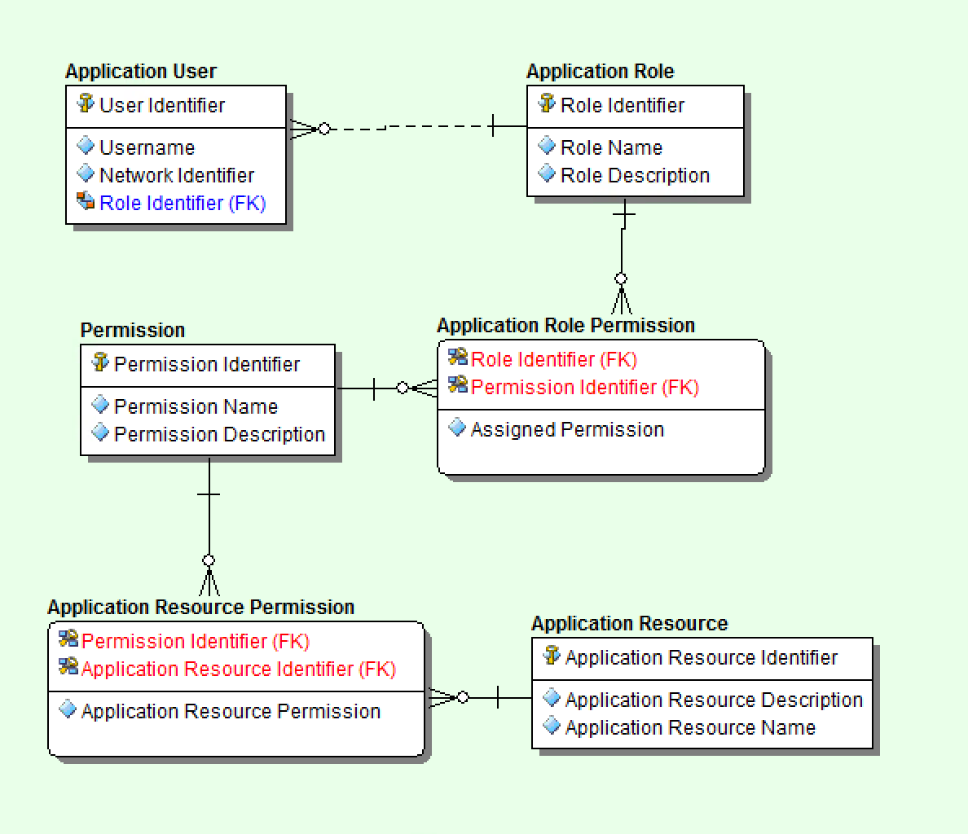

Data Ingest & Processing (INPUT): This layer of the LDM describes all the business entities that will be used to ingest predictive models and matrix data for the model before processing any claim(s) against the predictive model.

### BCDSS Data Ingest and Processing

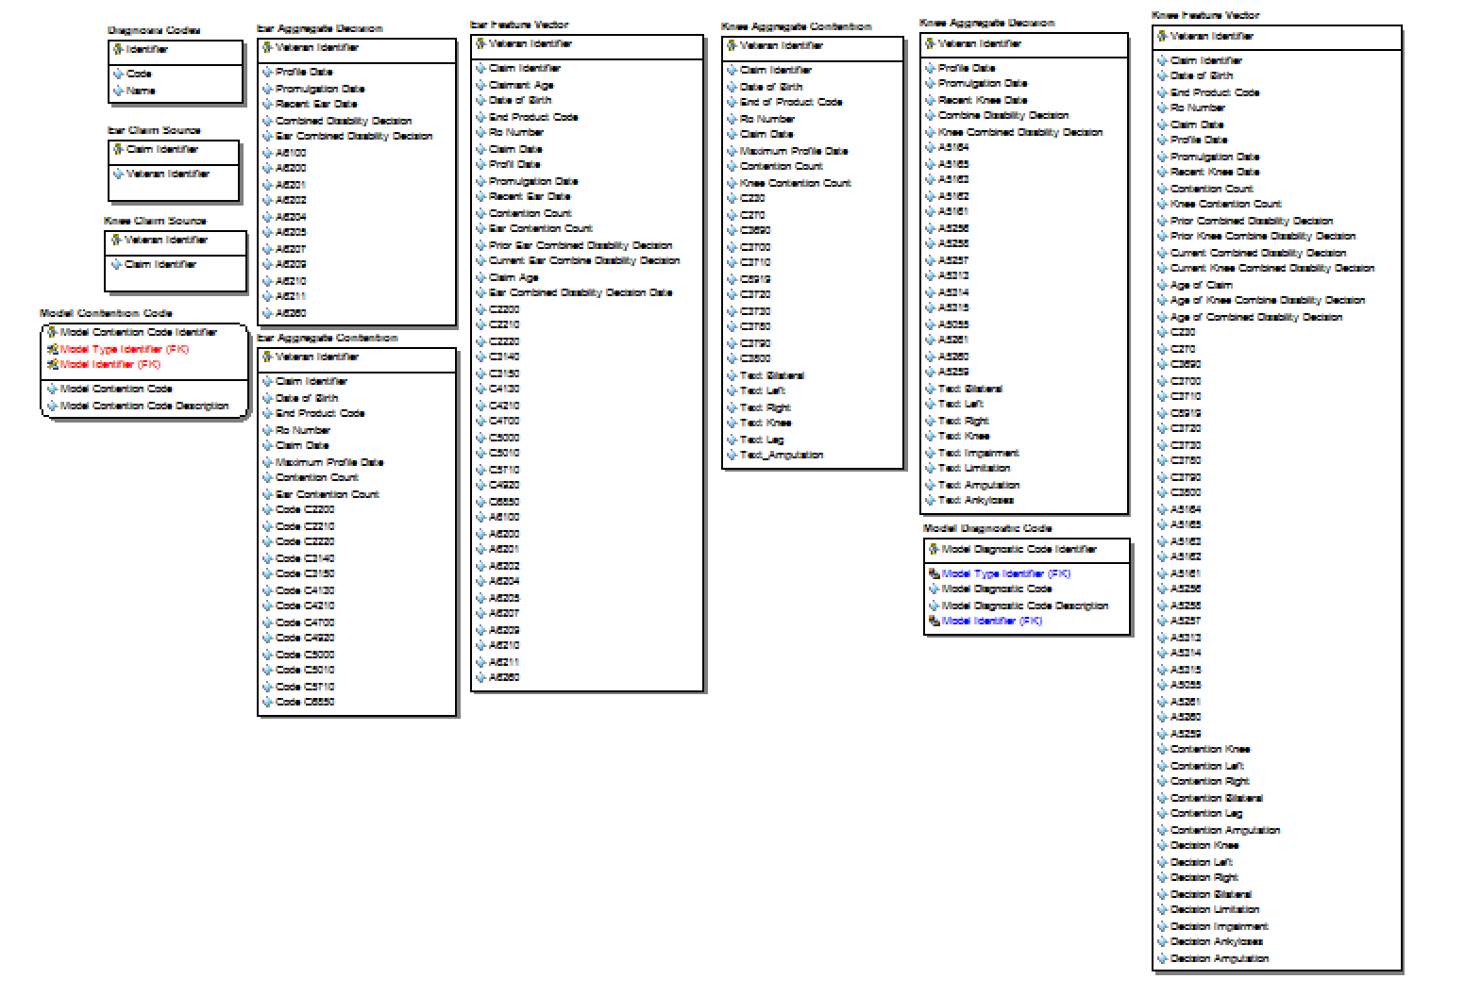

Predictive Model Meta Data: This layer of the LDM is used to track the peroperties and descriptive attributes of each predictive model. It does not inclue the run-time data supporting the model but rather the attributes used in the calculation of model results at run time.

### BCDSS Predictive Model Meta Data

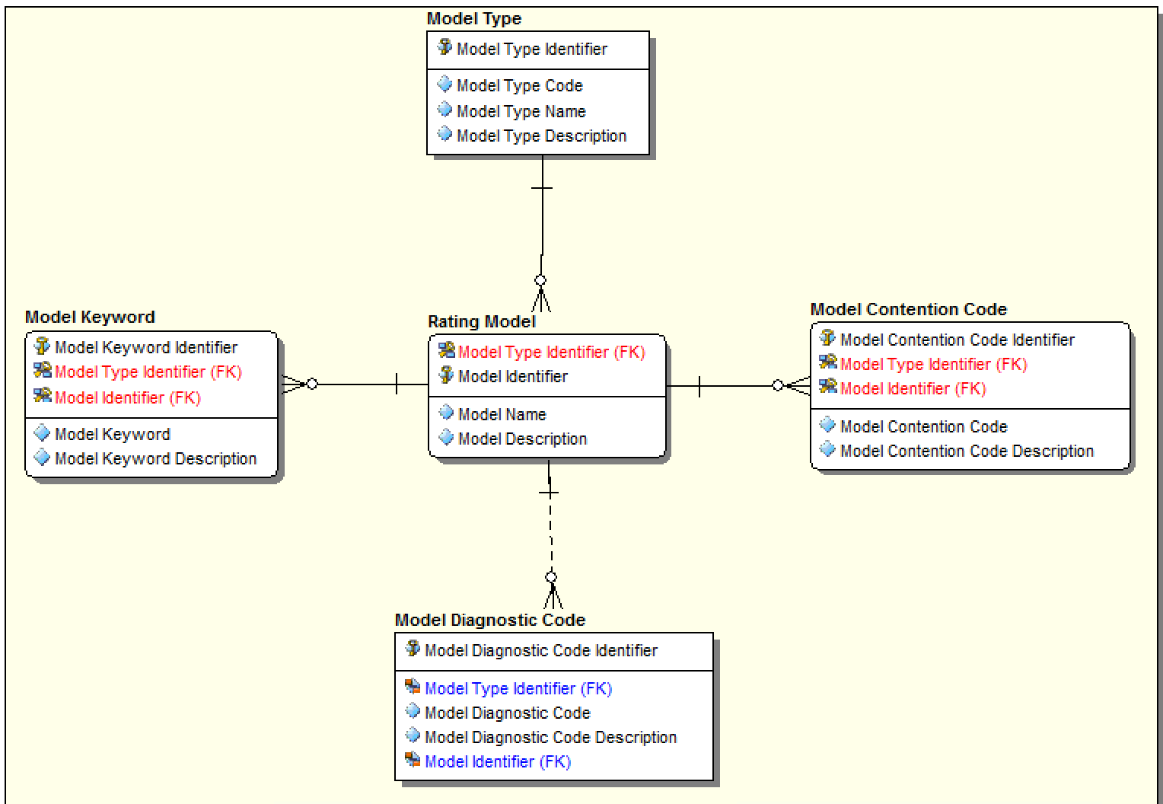

### The BCDSS CDM Data Dictionary – *Additions in Future Iteration*

The outline below is the data dictionary that defines each of the high level business entities.

| **Entity Name** | **Object Type** | **Definition** |
| --- | --- | --- |
| User | Entity | A VA employee or contractor that has rights to access BCDS application for performing claims analysis |
| Ear | Entity | A predefined set of Ear Claim Benefit data rules, enumerations and statistical model that can be use to predict future VA potential claims for a Claimant |
| Keen | Entity | A predefined set of Knee Claim Benefit data rules, enumerations and statistical model that can be use to predict future VA potential claims for a Claimant |
| Rating Model | Entity | A predefined set of data rules, enumerations and statistical model that can be use to predict future VA potential claims for a Claimant |
| Target Claim | Entity | A submitted benefit request for VA benefit entitlement a Claimant has requested to be provided based on service |
| Claimant | Entity | A veteran or family member of a veteran of the US Defense Department that have applied for benefits entitlement |
| Role | Entity | The BCDS role assigned to a VA employee or contractor that is used to determine the person's privileges. List of BCDS roles: Rater, Model Agent, Administrator, Modeling Analyst |
| Rating Model Result | Entity | A predefined set of data rules, enumerations and statistical model that can be use to predict future VA potential claims for a Claimant |
| Permission | Entity | The security rights that is used to determine what a role can perform within BCDS application |

# Detailed Design

This section describes the proposed design in detail. Provide the necessary information for the development team to integrate the hardware components and write the software code, so that the hardware and software components will provide a functional product. This is the detailed design, based upon the conceptual design (high level) that was described in the document up to this point.

Note: Every design item should map back to the Requirements Specification Document. These should be captured in the Requirement Traceability Matrix (RTM).

## Hardware Detailed Design

The information requested in this section may be provided by Engineering and/or the Developers. The information provided here is mainly for use by Engineering and Operations.

In this section, provide enough information for the developers to build and/or procure the system’s hardware. The level of detail requested should be treated as a general guideline and can be omitted if it needs to be filled in by Engineering and Operations.

Note: If this section becomes too lengthy, consider incorporating it as an appendix or reference it in a separate document. Add additional diagrams, if necessary, to describe each component and its functions.

Include the following information (as applicable):

* How much compute capacity? (MFLOPS, TPMs etc.)
* System Memory
* Local and Shared storage
* Network requirements (Bandwidth, Latency etc.)
* Public or Private cloud

## Software Detailed Design

This section provides conceptual and final detailed information associated with the design of the software being delivered. This should be an extension of the corresponding section from Section 3.1, but should contain additional detail as the project progresses.

### Conceptual Design

This section introduces the conceptual information that establishes the basis for how the software will be built.

#### Product Perspective

This subsection of the SDD should put the product into perspective with other related products. If the product is independent and completely self-contained, it should be stated here. If the SDD defines a product that is a component of a larger system, then this subsection should relate the requirements of that larger system to functionality of the software and should identify interfaces between that system and the software.

A block diagram showing the major components of the larger system, interconnections, and external interfaces can be helpful.

Sections of the Requirements Specification Document (RSD) can be referenced in the subsections, if applicable.

##### User Interfaces

This subsection should specify the logical characteristics of each interface between the software product and its users. This includes those configuration characteristics necessary to accomplish the software requirements (e.g., screens, roll and scroll, GUI interface).

Recommendation: Create a block diagram showing the user interfaces.

##### Hardware Interfaces

This subsection should specify the logical characteristics of each interface between the software product and the hardware components of the system. This includes configuration characteristics (for example, hardware platform or mainframe versus personal computer). It also covers matters such as what devices the system will support, how they will be supported, and protocols. Examples include scanners, pen driven devices, and radio frequency devices.

Recommendation: Create a block diagram showing the hardware interfaces.

##### Software Interfaces

This subsection should specify the use of other required software products (e.g., VA Kernel, VA FileMan, Windows NT); and interfaces with other applications or other systems such as commercial off-the-shelf (COTS) or national databases. Specify the application interfaces (e.g., the linkage between an accounts receivable system and a general ledger system and a COTS software package that will be interfaced using an existing interface). This section should provide the following information for each required software product:

* Name
* Version number
* Discussion of the purpose of the interfacing software as related to this software product
* Definition of the interface in terms of message content and format (e.g., Health Level Seven [HL7], electronic data interchange).

##### Communications Interfaces

This subsection should specify the various interfaces to communications such as local network protocols, e-mail, Transmission Control Protocol (TCP), modems.

Recommendation: Create a block diagram showing the communications interfaces.

##### Memory Constraints

This subsection should specify any applicable characteristics and limits on memory or partition size.

##### Special Operations

This subsection should specify the special operations required by the user such as backup, recovery, and archiving operations.

This section should also include any operations for external devices or COTS systems.

#### Product Features

This subsection should provide a summary of the major features of the software.

For example, an SDD for an accounting program might use this section to address customer account maintenance, customer statement, and invoice preparation without mentioning the vast amount of detail that each of those features requires.

Note: For clarity, remember these items when creating this section of the SDD:

* The features should be organized in a way that makes the list of features understandable to the customer or to anyone else reading the document for the first time.
* Textual or graphical methods can be used to show the different features and their relationships.
* Such a diagram is not intended to show a design of a product, but simply shows the logical relationships among variables.

#### User Characteristics

This subsection should describe the general characteristics of the intended users of the product, including experience and technical expertise. It should not be used to state specific requirements but rather should provide the reasons why certain specific requirements are specified in the RSD.

#### Dependencies and Constraints

This subsection should provide a description of any other items that will limit the developer’s options. The following list includes items that limit the developer’s options.

* Regulatory policies
* Hardware limitations (for example, signal timing requirements)
* Interfaces to other applications
* Parallel operation
* Audit functions
* Control functions
* Higher-order language requirements
* Reliability requirements
* Criticality of the application
* Safety and security considerations
* Usability (including 508 compliance)

This section of the SDD should contain all the software design to a level of detail sufficient to enable programmers to develop a system that satisfies the requirements defined in the RSD. It should be detailed so as to make it easy for technical staff to find the methods to complete the designed function.

These requirements should, at minimum, include the following items:

* An indication of the associated requirement(s) in the RSD which is being designed
* A description of the functionality being designed
* The design entities (and their attributes) affected
* The algorithm executed (where appropriate) to implement the functionality.

Because the Dependencies and Constraints section is often the largest and most important part of the SDD, the following principles apply:

* Specific design should be cross-referenced to earlier, related documents (e.g., the RSD).
* All design should be uniquely identifiable.
* Items in this section should be identified from a technical level rather than an end user level. (i.e., an option name should be identified rather than the menu text for that option).

### Specific Requirements

#### Database Repository

The Database Repository section in the RSD can be referenced in this section.

If a logical database design is a part of the system, it should be listed here. Logical database design should specify the logical requirements for any information that is to be placed into a database. This may include:

* Types of information used by various functions
* Frequency of use
* Accessing capabilities
* Data entities and their relationships
* Integrity constraints
* Data retention requirements.

Recommendation: Create a block diagram showing the databases and where the data resides.

#### System Features

Describe the system features, functional requirements, sub-requirements, etc. which can be organized in an outline format that matches the RSD. Specific formatting and organization of the paragraphs (i.e., section numbering) is left to the discretion of the author and is dependent on the level of detail essential to fully describe the design. Some designs may only require two levels; others may require multiple levels. The information necessary to define the items or to specify modifications to the items affected by the functionality being designed should be provided in the appropriate design element tables. Where feasible, instead of duplicating the RSD, it can be referenced via a link, to avoid unnecessary duplication. The key goal is to provide traceability to requirements.

#### Design Element Tables

The design element tables are provided for your convenience. Copy each table as many times as necessary to address multiple items within each section. Add rows and headings to the tables to provide any additional required information to define the item or to specify the modifications to the item. Numbering of the design element tables to align them underneath the applicable requirement or sub-requirement is recommended, but is left to the author’s discretion. For that reason they are not numbered in this template.

##### Routines (Entry Points)

This section is an illustration that is VistA specific. The authors are free to organize this information by technology, different templates, or optional sections depending on the task at hand.

Complete the table for each routine affected by the functionality being designed.

Table 14: Routines (Instructions)

| Routines | Instructions |
| --- | --- |
| **Routine Name** | List the routine affected by the functionality being designed. |
| **Enhancement Category** | Check the appropriate box: New, Modify, Delete, or No Change. |
| **RTM** | List the RSD item number within the SDD (i.e., If the RSD has a requirement of 3.3.1, add Support for a new API, then in this column list RSD Requirement 3.3.1) |
| **Related Options** | List options that directly call or are called by the routine. |
| **Related Routines** | List routines that directly call or are called by the routine. |
| **Data Dictionary (DD) References** | List files that reference the routine through input transforms, cross reference logic, etc. |
| **Related Protocols** | List protocols that reference or are referenced by the routine. |
| **Related Integration Control Registrations (ICRs)** | List proposed new ICRs and subscribed ICRs. Also, list any obscure Supported ICRs. |
| **Data Passing** | Check the appropriate box. Also a short description of what invokes the new/changed routine should be included in this section. An example of such a description would be a note that the new/changed routine will be invoked as part of a function call or it would be invoked through user menu-driven options, system protocols, HL7 Logical Links, etc. This section refers specifically to the change implemented with the design. |
| **Input Attribute Name and Definition** | List the Input Attributes passed into the new or changed routine logic. Each attribute should be defined. |
| **Output Attribute Name and Definition** | List the Output Attributes returned from the new or changed routine logic. Each attribute should be defined. |
| **Current Logic** | Define the current logic in the routine that the design will modify. If this is new code, enter “N/A”. |
| **Modified Logic (Changes are in bold)** | Define the logic in the routine that the design will implement. |

Table 15 (Grouping): Routines

| Routines | Activities | | | |
| --- | --- | --- | --- | --- |
| **Routine Name** |  | | | |
| **Enhancement Category** | New | Modify | Delete | No Change |
| **RTM** |  | | | |
| **Related Options** |  | | | |

| Related Routines | Routines “Called By” | Routines “Called” |
| --- | --- | --- |
|  |  |  |

| Routines | Activities | | | | |
| --- | --- | --- | --- | --- | --- |
| **Data Dictionary (DD) References** |  | | | | |
| **Related Protocols** |  | | | | |
| **Related Integration Control Registrations (ICRs)** |  | | | | |
| **Data Passing** | Input | Output Reference | Both | Global Reference | Local |
| **Input Attribute Name and Definition** | Name:  Definition: | | | | |
| **Output Attribute Name and Definition** | Name:  Definition: | | | | |

| Current Logic |
| --- |
|  |

| Modified Logic (Changes are in bold) |
| --- |
|  |

##### Templates

Complete Table 16 for each template affected by the functionality being designed. A short description of what change will be made to the templates should be included in this section.

Note: If preferred, copy and paste this section directly from VA FileMan DDs instead of using the tables.

Table 16: Templates (Instructions)

| Templates | Instructions |
| --- | --- |
| **Template Name** | Identify the template affected by the functionality being designed |
| **Enhancement Category** | Check the appropriate box: New, Modify, Delete, or No Change. |
| **RSD Traceability** | List the Requirement Specification Document (RSD) item number within the SDD (i.e., If the RSD has a requirement of 3.3.1, add Support for a new API, then this column should list RSD Requirement 3.3.1) |
| **Template Type** | Indicate the type of template identified (Sort, Input, or Print). |
| **Related Options** | List options that directly call or are called by the template. |
| **Related Routines** | List routines that directly call or are called by the template. |
| **Data Dictionary (DD) References** | List files/fields that reference the template(s) through input transforms, and cross reference logic. |
| **Global References** | List the ICRs for global references that are outside your namespace. |

Table 17: Templates

| Templates | Description | | | |
| --- | --- | --- | --- | --- |
| **Template Name** |  | | | |
| **Enhancement Category** | New | Modify | Delete | No Change |
| **RSD** |  | | | |
| **Template Type** | Sort | Input | Print | Other |
| **Related Options** |  | | | |

| **Related Routines** | **Routines “Called By”** | **Routines “Called”** |
| --- | --- | --- |
|  |  |  |

| Routines | Description |
| --- | --- |
| **Data Dictionary (DD) References** |  |
| **Global References** |  |

##### Bulletins

If the project develops or affects bulletins, then complete this section; if not then state that the section is not applicable and delete the tables and content of the section. Complete the table for each bulletin affected by the functionality being designed. A short description of what change will be made to the bulletins should be included in this section.

Note: If preferred, copy and paste this section directly from VA FileMan DDs instead of using the tables.

Table 18: Bulletins (Instructions)

|  |  |
| --- | --- |
| Bulletins | Instructions |
| **Bulletin Name** | List the specific bulletin affected by the functionality being designed. |
| **Enhancement Category** | Check the appropriate box: New, Modify, Delete, or No Change. |
| **RTM** | List the RSD item number within the SDD (i.e., If the RSD has a requirement of 3.3.1, add Support for a new API, then in this column list RSD Requirement 3.3.1). |
| **Related Options** | List options that directly send the bulletin. |
| **Related Routines** | List routines that directly send the bulletin. |
| **Mail Subject** | List the subject of the mail message, i.e., which bulletin this affects. |
| **Mail Group** | List the mail group (recipients) of the mail message. |
| **Parameters** | List necessary parameters. |
| **Data Dictionary (DD) References** | List files/fields that reference the bulletin(s) through input transforms, cross reference logic, etc. should be listed under Data Dictionary (DD) References. |

Table 19: Bulletins

| Bulletins | Description | | | |
| --- | --- | --- | --- | --- |
| **Bulletin Name** |  | | | |
| **Enhancement Category** | New | Modify | Delete | No Change |
| **RTM** |  | | | |

| Related Routines | Routines “Called By” | Routines “Called” |
| --- | --- | --- |
|  |  |  |

| Routines | Description |
| --- | --- |
| **Mail Subject** |  |
| **Mail Group** |  |
| **Parameters** |  |
| **Data Dictionary (DD) References** |  |

##### Data Entries Affected by the Design

Provide the following data for each field to be created, modified, or deleted or provide a “Before and After: Data Entries Affected by the Design.”

Identify the entries affected by the design. If a blanket change will be made to each entry affected, that change should be defined in this table.

Only changes that are unique to each record should be defined in the Unique Record(s) section (Section 6.2.2.3.5). Redundant information should not be entered into each chart in the Unique Record(s) section.

Table 20: Data Entries Affected by the Design

| Field Name | Current Value | New Value |
| --- | --- | --- |
|  |  |  |

##### Unique Record(s)

List the unique record ID(s) that will be affected by the changes implemented by the design. This is commonly done in the .01 field. The values defined in the Current Value and New Value columns should be the exact value of the data. For each unique record ID, copy this table and provide the information.

Table 21: Unique Record ID

| Field Name(s) | Current Value | New Value |
| --- | --- | --- |
|  |  |  |

##### File or Global Size Changes

Indicate the change to the size of the file or global as a result of the design implemented with this description. Global size changes tie back to the business requirements and RSD. Growth or reduction in the size of the global should be indicated in this section. If the file is static across all VistA systems, a blanket statement of how the change will affect the size of the global will suffice.

For example, “The National Procedure file is a new file and will require 8.7K of disk space to install.”

If a file is dynamic and its size may vary from VistA system to VistA system, the description should indicate the change in the file per record and the number of records that the site may anticipate. For example, if a field is being added to the patient file that will result in an increase of 7K per patient, the site can estimate the global growth based on the number of entries in that file.

Note: If the Capacity Planning analysis is available, then enter it here. If not, then use the Project Team projection.

Table 22: File or Global Size Changes

| File/Global Name(s) | Estimated Increase | Estimated Decrease |
| --- | --- | --- |
|  |  |  |

##### Mail Groups

Complete the table for each of the mail groups affected by the functionality being designed. A short description of what changes will be made to the affected mail groups should be included in this section.

Note: If preferred, this can be captured directly from VA FileMan DDs after the fact.

Table 23: Mail Groups (Instructions)

| Mail Groups | Instructions |
| --- | --- |
| **Mail Group Name** | List the name of the mail group being modified. The mail group name may include a domain name. |
| **Enhancement Category** | Check the appropriate box: New, Modify, Delete, or No Change. |
| **Related Options** | List options that directly reference the file. |
| **Related Routines** | List routines that reference the mail group. |
| **Data Dictionary (DDs) References** | List files that reference the mail group through input transforms, cross-reference logic, etc. |
| **Related Protocols** | List protocols that directly reference the mail group. |
| **Mail Group Description** | Describe the purpose for the mail group. |
| **Self-Enrollment Allowed** | Check the appropriate box either Yes or No. |
| **Type** | Check the appropriate box either Public or Private. |

Table 24: Mail Groups

| Mail Groups | Activities | | | |
| --- | --- | --- | --- | --- |
| **Mail Group Name** |  | | | |
| **Enhancement Category** | New | Modify | Delete | No Change |
| **Related Options** |  | | | |

| Related Routines | Routines “Called By” | Routines “Called” |
| --- | --- | --- |
|  |  |  |

| Mail Groups | Instructions | |
| --- | --- | --- |
| **Data Dictionary (DD) References** |  | |
| **Related Protocols** |  | |
| **Mail Group Description** |  | |
| **Self-Enrollment Allowed** | Yes | No |
| **Type** | Public | Private |

##### Security Keys

This section lists the specific security keys affected by the functionality being designed. A short description of the changes that will be made to the security keys affected should be included in this section.

Note: If preferred, this can be captured directly from VA FileMan DDs after the fact.

Table 25: Security Keys (Instructions)

| Security Keys | Instructions |
| --- | --- |
| **Security Key Name** | List the specific name of the security key being modified. |
| **Enhancement Category** | Check the appropriate box: New, Modify, Delete, or No Change. |
| **Related Options** | List options that directly reference the security key. |
| **Related Routines** | List routines that reference the security key. |
| **Data Passing** | Check the appropriate box. Enter a short description of an event that would trigger the new/changed routine, for example, a note that the change to the security key will be referenced through user menu driven options, routines, etc. This section refers specifically to the change implemented with the design. |
| **Security Key Description** | List a brief description of the security key. |
| **Subordinate Keys** | List any subordinate keys. |
| **Mutually Exclusive Keys** | Enter the name of a key that may not be held jointly with this one. |
| **Granting Condition Logic** | Define the logic for the Granting Condition of the Security Key affected by the functionality being designed. |
| **Current Logic** | If the security key currently has a granting condition, define the current logic for that granting condition. If the security key did not exist before, indicate that there is currently no security key. |
| **Modified Logic  (Changes are in bold)** | Define the granting condition that the design will implement. If the security key is new to the field, define the logic here. |
| **Hierarchical Precedence** | Define which key is used if one key will take precedence over another key. |

Table 26: Security Keys

| Security Keys | Activities | | | |
| --- | --- | --- | --- | --- |
| **Security Key Name** |  | | | |
| **Enhancement Category** | New | Modify | Delete | No Change |
| **Related Options** |  | | | |

| Related Routines | Routines “Called By” | Routines “Called” |
| --- | --- | --- |
|  |  |  |

| Security Keys | Activities | | | | |
| --- | --- | --- | --- | --- | --- |
| **Data Passing** | Input | Output | Both | Global Reference | Local Reference |
| **Security Key Description** |  | | | | |
| **Subordinate Keys** |  | | | | |
| **Mutually Exclusive Keys** |  | | | | |
| **Granting Condition Logic** |  | | | | |

| Current Logic |
| --- |
|  |

| Modified Logic (Changes are in bold) |
| --- |
|  |

| Security Keys | Activities |
| --- | --- |
| **Hierarchical Precedence** |  |

##### Options

Complete the table for each of the options affected by the functionality being designed. A short description of the changes that will be made to the options affected should be included. Changes to the OPTION file (#19) are to be included, not the functionality of the option invoked.

Note: If preferred, this can be captured directly from VA FileMan DD after the fact.

Table 27: Options (Instructions)

| Options | Instructions |
| --- | --- |
| **Option Name**  **(MENU TEXT field)** | Enter the name of the option affected. |
| **Enhancement Category** | Check the appropriate box: New, Modify, Delete, or No Change |
| **Associated Menu Options that will invoke this reference** | List the menu type options on which the respective option is or will be contained. |
| **Data Passing** | Check the appropriate box. Also a short description of what invokes the new/changed routine should be included in this section. An example of such a description would be a note that the change to the option will be referenced through VA Mailman server messages, user selection of the option from the VA Kernel Menu Management system, etc. This section refers specifically to the change implemented with the design. |
| **Menu Text Description** | Enter the name of the option as it will be displayed to the user within the menu system. |
| **Option Type** | Specify the type of option |
| **Option Definition** | Provide all the information necessary to fully define the option. Include options that are included in the menu, if applicable. |
| **Current Entry Action Logic** | Define the current logic for the entry action of the option affected by the functionality being designed. If the entry action did not exist before, indicate that there currently is no entry action. |
| **Modified Entry Action Logic (Changes are in bold)** | Define the entry action that the design will implement. If the entry action is new to the field, define the logic here. |
| **Current Exit Action Logic** | Define the current logic for the exit action of the option affected by the functionality being designed. If the exit action did not exist before, indicate that there currently is no exit action. |
| **Modified Exit Action Logic**  **(Changes are in bold)** | Define the exit action that the design will implement. If the exit action is new to the field, define the logic here. |

Table28: Options

| Options | Activities | | | | | | | | | | |
| --- | --- | --- | --- | --- | --- | --- | --- | --- | --- | --- | --- |
| **Option Name** |  | | | | | | | | | | |
| **Enhancement Category** | New | Modify | | | | Delete | | | No Change | | |
| **Associated Menu Options that will invoke this reference** |  | | | | | | | | | | |
| **Data Passing** | Input | | Output | | Both | | | Global Reference | | | Local Reference |
| **Menu Text Description** |  | | | | | | | | | | |
| **Option Type** | Edit | | | Print | | | Menu | | | Inquire | |
| Action | | | Run Routine | | | Other | | |  | |
| **Associated Routine** |  | | | | | | | | | | |
| **Option Definition** |  | | | | | | | | | | |

| Current Entry Action Logic |
| --- |
|  |

| Modified Entry Action Logic (Changes are in bold) |
| --- |
|  |

| Current Exit Action Logic |
| --- |
|  |

| Modified Exit Action Logic (Changes are in bold) |
| --- |
|  |

##### Protocols

Complete the table for each of the protocols affected by the functionality being designed. A short description of the changes that will be made to the protocols affected should be included in this section. Changes to the PROTOCOL file (#101) are to be included, not the functionality of the protocol invoked.

Note: If preferred, this can be captured directly from VA FileMan DDs after the fact.

Table29: Protocols (Instructions)

| Protocols | Instructions |
| --- | --- |
| **Protocol Name** | List the name of the protocol affected. |
| **Enhancement Category** | Check the appropriate box: New, Modify, Delete, or No Change. |
| **Associated Protocols** | List the ancestors of the protocol being designed, i.e., those protocols that contain the respective protocol as an item. |
| **Data Passing** | Check the appropriate box. An event that would trigger the new/changed protocol should be included in this section. An example would be a note that the change to the protocol will be referenced through the VA event driver, List Manager, user selection of a protocol from the VA Kernel Menu Management system. This section refers specifically to the change implemented with the design. |
| **Item Text Description** | Enter the protocol's text as it appears to the user on the menu or sub-header. |
| **Protocol Type** | Define the type of protocol to be executed |
| **Associated Routine** | List any associated routines affected by the protocol being designed. |
| **Current Entry Action Logic** | Define the current logic for the entry action of the protocol affected by the functionality being designed. If the entry action did not exist before, indicate that there currently is no entry action. |
| **Modified Entry Action Logic  (Changes are in bold)** | Define the entry action that the design will implement. If the entry action is new to the field, define the logic here. |
| **Current Exit Action Logic** | Define the current logic for the exit action of the protocol affected by the functionality being designed. If the exit action did not exist before, indicate that there currently is no exit action. |
| **Modified Exit Action Logic  (Changes are in bold)** | Define the exit action that the design will implement. If the exit action is new to the field, define the logic here. |

Table 30: Protocols

| Protocols | Activities |
| --- | --- |
| **Protocol Name** |  |
| **Enhancement Category** | New  Modify  Delete  No Change |
| **Associated Protocols** |  |
| **Data Passing** | Input  Output  Both  Global Reference  Local Reference |
| **Item Text Description** |  |
| **Protocol Type** | Action  Menu  Protocol  Protocol Menu  Limited Protocol  Extended Action  Dialog  Other |
| **Associated Routine** |  |

| Current Entry Action Logic |
| --- |
|  |

| Modified Entry Action Logic (Changes are in bold) |
| --- |
|  |

| Current Exit Action Logic |
| --- |
|  |

| Modified Exit Action Logic (Changes are in bold) |
| --- |
|  |

##### Remote Procedure Call (RPC)

Complete the table for each RPC affected by the functionality being designed.

Note: If preferred, this can be captured directly from VA FileMan DDs after the fact.

Table 31: RPCs (Instructions)

| RPCs | Instructions |
| --- | --- |
| **Name** | List the specific name of the RPC affected. |
| **TAG^RTN** | List the tag (label) and routine. |
| **Input Parameters** | This field is used to identify an input parameter for the API. |
| **Results Array** | This field tells the RPC Broker how to process the resulting data from the call. |
| **Description** | Provide a brief description of the RPC affected. |

Table 32: RPCs

| RPCs | Activities | | |
| --- | --- | --- | --- |
| **Name** |  | | |
| **TAG^RTN** |  | | |
| **Input Parameters** |  | | |
| **Results Array** | Single Value | Array | Word Processing |
| Global Array | Global Instance |  |
| **Description** |  | | |

##### Constants Defined in Interface

Provide the name and description.

Table 33: Constants Defined in Interface

| Name | Description |
| --- | --- |
|  |  |

##### Variables Defined in Interface

Provide the name, type, and description.

Table 34: Variables Defined in Interface

| Name | Type | Description |
| --- | --- | --- |
|  |  |  |

##### Types Defined in Interface

Provide the name, type, and description.

Table 35: Types Defined in Interface

| Name | Type | Description |
| --- | --- | --- |
|  |  |  |

##### GUI

List the GUI affected by the functionality being designed and include a short description of the changes made to the affected GUI. The headers in the following tables have names for the information outlined. There are a number of items in this section that would generally be global information and visible to all other aspects.

Table 36: GUI

| Unit Name | Description |
| --- | --- |
|  |  |

##### GUI Classes

Table 37: GUI Classes (Instructions)

| GUI Classes | Instructions |
| --- | --- |
| **Class Name** | List the name of the class affected. The headers in the following tables have names for the information outlined. Note that only the new properties and methods for a class are listed below. All ancestor properties and methods are still available and unchanged. |
| **Derived From Class** | List the class that this is derived from, its parent and any interfaces listed as part of this class. |
| **Purpose** | Describe the functionality that users can access from this class and related form, if any. |

Table 38: GUI Classes

| GUI Classes | Instructions |
| --- | --- |
| **Class Name** |  |
| **Derived From Class** |  |
| **Purpose** |  |

##### Current Form

Provide a screen capture or graphical representation of the current layout.

##### Modified Form

Provide a screen capture or graphical representation of the layout that the design will implement.

##### Components on Form

Table 39: Components on Form

| Name | Type | Description |
| --- | --- | --- |
|  |  |  |

##### Events

Table 40: Events

| Name | Type | Description |
| --- | --- | --- |
|  |  |  |

##### Methods

Table 41: Methods

| Method Name | Procedure/Function | Description |
| --- | --- | --- |
|  |  |  |

##### Special References

Include references that are not listed elsewhere.

| Special Reference Name | Type | Description |
| --- | --- | --- |
|  |  |  |

##### Class Events

Table 42: Class Events

| Name | Type | Description |
| --- | --- | --- |
|  |  |  |

##### Class Methods

Table 43: Class Methods

| Name | Procedure/Function | Description |
| --- | --- | --- |
|  |  |  |

##### Class Properties

Table 44: Class Properties

| Class Properties Name | Type | Visibility | Description |
| --- | --- | --- | --- |
|  |  |  |  |

##### Uses Clause

Use this section to provide a uses clause that lists the other units (code or form units) that this unit will use. This may be documented in the form of a Unified Modeling Language (UML) drawing.

##### Forms

This section lists the forms that will be affected or created by the functionality being designed. A short description of the change that will be made to the forms should be included.

Table 45: Forms (Instructions)

| Forms | Instructions |
| --- | --- |
| **Form Name** | List the name of the form affected by the functionality being designed. |
| **Enhancement Category** | Check the appropriate box: New, Modify, Delete, or No Change. |
| **Form Functionality** | Describe the form’s functionality and refer to the usage of the form. An example of such a description is “This form is used to enter patient demographic data.” |
| **Current Form Layout** | Define the current form layout that the design will modify. If this is a new form, enter “N/A”. |
| **Modified Form Layout (Changes are in bold)** | Define the form layout that the design will implement. |

Table 46: Forms

| Forms | Description | | | |
| --- | --- | --- | --- | --- |
| **Form Name** |  | | | |
| **Enhancement Category** | New | Modify | Delete | No Change |
| **Form Functionality** |  | | | |

| Current Form Layout |
| --- |
|  |

| Modified Form Layout (Changes are in bold) |
| --- |
|  |

##### Functions

The functions affected by the capabilities being designed should be listed in this section. A short description of what change will be made to the functions and/or new functions should be included.

Table 47: Forms (Instructions)

| Functions | Instructions |
| --- | --- |
| **Function Name** | List the specific function affected by the capability being designed. |
| **Short Description** | List a short description of the change that will be made to the functions and/or new functions. |
| **Enhancement Category** | Check the appropriate box: New, Modify, Delete, or No Change. |
| **Related Options** | List the options that directly call or are called by the function. |
| **Related Routines** | List the routines that directly call or are called by the function. |
| **Data Dictionary (DD) References** | List the files that reference the function through input transforms, cross reference logic, etc. |
| **Related Protocols** | List the protocols that reference or are referenced by the function. |
| **Related Integration Control Registrations (ICRs)** | List proposed new ICRs and subscribed ICRs. Also, list any obscure Supported ICRs. |
| **Data Passing** | Check the appropriate box. An event that would trigger the new/changed function should be included in this section. An example of such a description would be a note that the new/changed function will be invoked as part of a function call or it would be invoked through system protocols, HL7 Logical Links, etc. This section refers specifically to the change implemented with the design. |
| **Input Attribute Name and Definition** | List the input attributes passed into the new or changed function logic. Each attribute should be defined. |
| **Output Attribute Name and Definition** | List the output attributes returned from the new or changed function logic. Each attribute should be defined. |
| **Current Logic** | Define the current logic in the function that the design will modify. If this is new code, enter “N/A”. |
| **Modified Logic (Changes are in bold)** | Define the logic in the function that the design will implement. |

Table 48: Forms

| Function Name | Activities | | | |
| --- | --- | --- | --- | --- |
| **Short Description** |  | | | |
| **Enhancement Category** | New | Modify | Delete | No Change |
| **Related Options** |  | | | |

| Related Routines | Routines “Called By” | Routines “Called” |
| --- | --- | --- |
|  |  |  |

| Function Name | Activities | | | | |
| --- | --- | --- | --- | --- | --- |
| **Data Dictionary (DD) References** |  | | | | |
| **Related Protocols** |  | | | | |
| **Related Integration Control Registrations (ICRs)** |  | | | | |
| **Data Passing** | Input | Output | Both | Global Reference | Local Reference |
| **Input Attribute Name and Definition** | Name: | | | | |
| Definition: | | | | |
| **Output Attribute Name and Definition** | Name: | | | | |
| Definition: | | | | |

| Current Logic |
| --- |
|  |

| Modified Logic (Changes are in bold) |
| --- |
|  |

##### Dialog

In this section list the changes to the DIALOG file (#.84).

Table 49: Dialog (Instructions)

| Dialog | Instructions |
| --- | --- |
| **Dialog Message (Description)** | List the specific message affected or needed by the changes being designed. |
| **Enhancement Category** | Select the appropriate category: New, Modify, Delete, or No Change. |
| **Dialog Message (Description) Condition** | Describe the dialog message (description) functionality. An example of such a description would be the condition that would trigger the output of the message (dialog). This section refers to the condition generating the message (dialog). |
| **Current Dialog Message (Description)** | Define the current dialog message (description) that the design will modify. If this is a new dialog message (description) enter N/A. |
| **Modified Dialog Message (Description)  (Changes are in bold)** | Define the dialog message (description) that the design will implement. |

Table 50: Dialog

| Dialog | Instructions | | | |
| --- | --- | --- | --- | --- |
| **Dialog Message (Description)** |  | | | |
| **Enhancement Category** | New | Modify | Delete | No Change |
| **Dialog Message (Description) Condition** |  | | | |
| **Current Dialog Message (Description)** |  | | | |
| **Modified Dialog Message (Description)  (Changes are in bold)** |  | | | |

##### Help Frame

A short description of what change will be made to the Help Frame text and/or new text should be included in this section. Help frames may be associated with options or with data dictionary fields to provide on-line instruction.

Table 51: Help Frame (Instructions)

| Help Frame | Instructions |
| --- | --- |
| **Help Frame Text** | List the text affected or needed by the changes being designed. |
| **Enhancement Category** | Check the appropriate box: New, Modify, Delete, or No Change. |
| **Help Frame Text Calling Mechanism** | Provide a short description of the mechanism used to call the Help Frame text in this section. An example of a mechanism would be the name of the routine or an explanation of how the Help Frame is called. An example of a calling mechanism would be the Standard VA FileMan API and the keystroke(s) that would trigger the output of the text. |
| **Current Help Frame Text** | List the current Help Frame Text that the design will modify. If new text enter N/A. |
| **Modified Help Frame Text (Changes are in bold)** | List the Help Frame Text that the design will modify. |

Table 52: Help Frame

| Help Frame | Description | | | |
| --- | --- | --- | --- | --- |
| **Help Frame Text** |  | | | |
| **Enhancement Category** | New | Modify | Delete | No Change |
| **Help Frame Text Calling Mechanism** |  | | | |

| Current Help Frame Text |
| --- |
|  |

| Modified Help Frame Text (Changes are in bold) |
| --- |
|  |

##### HL7 Application Parameter

Table 53: HL7 Application Parameter (Instructions)

| HL7 Application Parameter | Instructions |
| --- | --- |
| **HL7 Application Parameter Name** | List the HL7 Application Parameter affected or needed by the changes being designed. |
| **Enhancement Category** | Check the appropriate box: New, Modify, Delete, or No Change. |
| **Application Status** | Check the appropriate box in the applicable column for Current and Modified |
| **Facility Name** | List the current and modified value in the appropriate column. |
| **Country Code** | List the current and modified value in the appropriate column. |
| **HL7 Field Separator** | List the current and modified value in the appropriate column. |
| **HL7 Encoding Characters** | List the current and modified value in the appropriate column. |
| **Mail Group** | List the current and modified value in the appropriate column. |

Table 54: HL7 Application Parameter

| HL7 Application Parameter Name | Description |
| --- | --- |

|  |  |  |  |  |
| --- | --- | --- | --- | --- |
| **Enhancement Category** | New | Modify | Delete | No Change |

|  |  |  |  |  |
| --- | --- | --- | --- | --- |
| **Application Status** | Active | Inactive | Active | Inactive |

| Enhancement Category | Current | Modified |
| --- | --- | --- |
| **Facility Name** |  |  |
| **Country Code** |  |  |
| **HL7 Field Separator** |  |  |
| **HL7 Encoding Characters** |  |  |
| **Mail Group** |  |  |

##### HL7 Logical Link

Table 55: HL7 Logical Link (Instructions)

| HL7 Logical Link | Instructions |
| --- | --- |
| **HL7 Logical Link Parameter (LLP) Name** | List the specific HL7 Logical Link affected or needed by the changes being designed. |
| **Enhancement Category** | Check the appropriate box: New, Modify, Delete, or No Change. |
| **Node** | List the current and modified value in the appropriate column. |
| **Institution** | List the current and modified value in the appropriate column. |
| **Domain** | List the current and modified value in the appropriate column. |
| **Autostart** | List the current and modified value in the appropriate column. |
| **Queue Size** | List the current and modified value in the appropriate column. |
| **LLP Type** | List the current and modified value in the appropriate column. |

Table 56: HL7 Logical Link

| HL7 Logical Link | Description |
| --- | --- |
| **HL7 Logical Link Parameter Name** |  |

|  |  |  |  |  |
| --- | --- | --- | --- | --- |
| **Enhancement Category** | **New** | **Modify** | **Delete** | **No Change** |

| Enhancement Category | Current | Modified |
| --- | --- | --- |
| **Node** |  |  |
| **Institution** |  |  |
| **Domain** |  |  |
| **Autostart** |  |  |
| **Queue Size** |  |  |
| **LLP Type** |  |  |

##### COTS Interface

The specific communication method(s) and Application Interface(s) that will be created or modified for the COTS system being interfaced should be described in this section. A short description of the existing tools that will be used and any new tools that will be developed should also be included.

Table 57: COTS Interface (Instructions)

| COTS Interface | Instructions |
| --- | --- |
| **Communication Method** | List the specific communication method created or modified for the functionality being designed. |
| **Application Interface** | List the specific application interface created or modified for the functionality being designed. |

Table 58: COTS Interface

| COTS Interface | Description |
| --- | --- |
| **Communication Method** |  |
| **Application Interface** |  |

## Network Detailed Design

Provide enough detailed information about the communication requirements to build and/or procure the communication components for the system. This section should provide sufficient detail to support the procurement of hardware for the system installation. Include the following information in the form of detailed designs (as appropriate):

* Details of servers and clients to be included on each area network
* Specifications for bus timing requirements and bus control
* Format(s) for data being exchanged between components
* Diagrams showing connectivity between components, data flow (if applicable), and distances between components
* LAN topology.

## Security and Privacy

### Security

Describe specific security mechanisms at the application level, as guided by NIST 800-53 revision 3 (or most current version). Also, summarize the security mechanisms to be provided by the VA GSSs. Reference the Security Risk Assessment.

The following information should be provided to address security controls:

A high-level description of the security controls, grouped according to the 18 control families identified in NIST 800-53 revision 3 (or most current version). A description of all 18 control families must be addressed; if a control family is not applicable, then state that control family does not apply and explain why it does not apply.

A description of the specific security controls that will be provided by existing VA infrastructure or VA GSSs.

Describe the planned use by the application of the infrastructure’s centralized security mechanisms and VA GSSs (in particular, the identification and authentication, access control, and audit mechanisms), and infrastructure mechanisms, (e.g., Directory Services) to store user account information. Sufficient detail should be provided to show the feasibility of the integration and/or inter operation of application security mechanisms with infrastructure security mechanisms.

### Privacy

Identify privacy design considerations. Describe specific privacy mechanisms at the application. Describe how the application’s privacy requirements will be met. Reference the System Security Plan (SSP) and Privacy Impact Assessment (PIA).

## Service Oriented Architecture / ESS Detailed Design

This section provides details of provided and consumed services as follows:

* Consumed Services: Provide link to Service Description Document for each consumed service.
* Provided Services: Give service design for each provided service.

The information you provide here will be used to upload to the ESS Registry and Repository. At some point in the near future, we do not expect these SOA artifacts such as SLA, Service Description, etc. to be static documents. They will be dynamically generated from the ESS Registry and Repository tool in the form of reports. Any application and service integration design is also documented here.

A list of currently available Enterprise Shared Services is available here: <insert link to ESS list>

### Service Description for <Consumed Service Name>

Provide link to Service Description document for the consumed service. This section will repeat for each consumed service. The Service Description includes Service Interface and Service Level Definition (SLD) to address anticipated capacity requirements.

### Service Design for <Provided Service Name>

This section should describe the detailed service design for each ESS and SOA service needed to obtain an intended result. The Service Design includes Service Interface and Service Level Definition (SLD) to address anticipated capacity requirements.

This section will repeat for each **provided** service.

#### Introduction

##### Purpose and Scope of Service

This service was described at a high level in the charter document. Please refer to it here via a link.

##### Links to Other Documents

Provide links to other documents created for this service so far in the SOA lifecycle. At a minimum, provide links to:

* Service Charter
* Service Roadmap
* Service Description

#### Service Details

##### Service Identification

This section will be written as a table to provide a quick reference to the service's what, where, why and how - cheat sheet.

| Service Attribute | Value |
| --- | --- |
| Name and Alias (if any) | Name of the service and other names for the service, which might be used by someone searching for this service. Please follow ESS naming standards. |
| Overview | Brief textual overview of the service. |
| Version | Version number of the service being described here |
| Latest Status | This field shows the latest status for the above referenced version of this service! The status of a service shows the progress of the service from initiation through development, deployment, and eventual retirement. The status also has a status date associated with the status - and we will be using the latest one here in this document. Valid values include: Inception, Design, Provisioning, Certification / Testing, Operation, Deprecated, Retired, Rejected - Owner has decided not to develop the service. |
| Service Type | Used to define applicable architecture patterns. Examples (from Open Group):  • Interaction  • Process  • Information  • Partner  • Business Application  • Access  • Service Connectivity |
| Architecture Layer | Referred to as class in VA Service template. Used to define applicable architecture patterns and relationships to governing bodies. Examples:  • Solution  • Process  • Information  • Utility  • Underlying |
| Business Domain | Business Vertical or Business Division where this service belongs. |
| Service Domain | The service or technical domain that the service belongs to. Can be used to establish the namespace. |
| Business Organization and Owner | Person who approves this service & any changes. Include email. |
| Technical Organization and Owner | Person responsible for provisioning (specifying, acquiring certifying) this service. Include email. |
| Development Organization and Owner | Person who is responsible for the development processes and activities for this service. Include email. |
| Support Organization and Owner | Person who is responsible for the support of this service while in production. Include email. |
| Target Consumer Organization(s) and Owner(s) | Organizations and/or developers roles that service is intended for. |

##### Service Versions

|  |  |  |
| --- | --- | --- |
| Version Numbers | Current Status of Version | A Brief Description of the change implemented in that version |
| This version | Being Designed |  |
| Example: version 2 | Example: In production. Will be retired with this release. | Example: This release added the ability to look up a person by address.  Provide a link to each version of the service. |
| Example: version 1 | Example: Retired. | Example: This release provided the base minimum functionality to look up a person by name.  Provide a link to each version of the service. |

##### Summary of Design and Platform Details

###### SOA Pattern(s) Implemented

Name of the SOA pattern implemented – for instance, this may be a Pub/Sub model. Just a name and reference to the document or book with the pattern is sufficient for popular patterns or VA's own patterns. If you are using some esoteric pattern, more details will help.

###### COTS Platform vendor names and versions for hosting platform

Example, TIBCO.

#### Dependencies

The Dependency Model identifies other services, systems, databases, etc. that [Service Name] is dependent upon or interacts with to perform its function.

This section should clearly identify all sources and external systems that are accessed by this service to fulfill the service consumers’ request. This section should include diagrams to show as much detail as necessary to inform the developer. Provide a context diagram for the service.

Note: Here our primary audience includes the providers of the service. So this document in general will emphasize system components and sub-systems as much as external interactions.

#### Service Design Details

The next sub-section on Interface Technical Specs **could be** just a copy from the corresponding sub-section in Interface section in the Service Description Document. Here, you could provide more detail necessary for building this service but **the interface spec needs to be consistent between this document and the Service Description Document**. This section contains all information necessary to fully describe an interface published by this service...

##### Interface Technical Specs

The technical specification allows developers of service consumers to locate and discover the service for run time consumption.

###### Service Invocation Type

Such as: SOAP over HTTP, REST.

###### Service Interface Type

Such as: WSDL via Web Service 2.0

###### Service Name

Technical Service Name. Comply with ESS naming standards.

###### Interface

Link to WSDL or other interface document.

###### End Points

Provide if known! Calls that can be made into the service. Can be referenced to the WSDL or can be in a separate table.

###### Operations or Methods

In the table below, the technical names of the operations, inputs and outputs are used. Inputs and outputs, if parameters, must have a data type.

Non-primitive data types must be defined in the Service Information Model section.

This table could be generated automatically from the WSDL content or its equivalent.

Style can take any of these values: Parameters or Document; and One-way or Request-response or Solicit-response or Notification.

Use a separate column for the operation purpose if you wish.

You might use abbreviations in the Faults column and explain the abbreviations used below the table. For example, NF = Not Found, MI = Missing Input.

|  |  |  |  |  |  |
| --- | --- | --- | --- | --- | --- |
| Operation Name | Inputs | Outputs | Transactional Qualities if relevant (Updating?, Atomic?, Can participate in transaction?) | Pre and Post Conditions | Exception (s) |
|  |  |  |  |  |  |
|  |  |  |  |  |  |

Provide a link to the Service Information model so that the consumer of your system knows the schema for the input and output parameters.

###### Message Schemas

Provide definitions or links to definitions of the message(s) related to the service operations. These may be dependent on the implementation style and protocol binding of the interface.

##### Information Model

Even though this section looks similar to the corresponding section 3.2 in Service Description, remember that the primary objective here is to facilitate construction and to gain approvals from governing bodies. So you will provide more of a “white box” view of the design here to help your developers code the service.

###### Class Diagram and Description of Entities Involved

Map out all entities involved in the service: input, output, exceptions, entities manipulated in persistent media/DBs, intermediate entities created in memory etc.

###### Mappings from ELDM to Standards Based Schemas

Provide mappings from your native schema to any standards based schemas your service will use to communicate outside. For instance, if you are using HL7 based messages then you will show how data is converted from your native schema to HL7.

##### Behavior Model (AKA Use Case Realization)

The Behavior Model defines the actions and processes supported by the service. Actions and methods represented in the use cases and sequence diagrams shown below are further defined by the operation contracts and the message payloads.

###### Use Cases (Use Case Model)

Describe how this service fits into the larger use case model of the consumer. You may need multiple models for multiple consumers. Focus is **not** on the internal workings of the new service instead of the calls made from external consumers. Just a summary or the Use Case Diagram may be sufficient. List the alternative and exception flows. Reference the detailed design documents via a URL.

###### Interaction Diagrams

Cut and paste screen shot from RSA or similar tool or provide link to the model. Provide description to help developers build your service. The interaction diagrams should depict external interactions and internal sequences of calls between internal components. The sequence diagram should cut through all layers to show the main, alternate and exception flows.

#### Gap Analysis

Provide a Gap Analysis (Reference) to demonstrate compliance of this service with various standards, policies, guidelines and laws. The Gap Analysis may take the form of a matrix as shown in the sample below. This will help the governance boards expedite your request.

| Design Elements🡪  Policies / SLD elements etc.↓ | Design  Element A | Design  Element B | Design  Element C | Comment for non-conformance |
| --- | --- | --- | --- | --- |
| Policy X | Match |  |  |  |
| Policy Y |  | Partial |  |  |
| Policy Z |  |  |  | Commercial encryption server in prod will have to address this policy. |
| Policy A |  |  |  | Compliance with this policy not required until next year. |
| New / Additional Features |  |  | New element minimizes manual intervention |  |

##### Variances from Enterprise Target Architecture

This list of “variances” will become a submission to the ESS dispensation process.

##### Variances from SLDs

This list of “variances” will become a submission to the ESS dispensation process.

##### Variances from Standards and Policies

This list of “variances” will become a submission to the ESS dispensation process.

##### Justification for Exceptions and Mitigation

This section will list out any non-functional and functional requirements that are not being met. The non-conformance may be in violation of elements of SLDs, enterprise architecture (TRM Technology Reference Model), privacy policies or guidelines. For each exception provide:

1. Reasons for non-conformance (cost, time, technology, etc.)
2. Mitigating actions taken to reduce the impact of non-conformance
3. Plan (roadmap) to come back into conformance

This list can grow depending on what the Review bodies may ask for.

# External System Interface Design

This section details interfaces external to system, that are NOT services (ESS/SOA). Typically, these may include, RPCs, Flat Data Files etc.

External systems are systems that are not within the scope of the system under development, regardless of whether the other systems are managed by the vendor or its client.

In this section, describe the interface(s) between the system under development (i.e., the system that is the subject of this SDD) and external systems and/or subsystem(s).

It is best to illustrate these sections with annotated diagrams to clearly identify the various elements of the interfaces.

## Interface Architecture

Describe the interface(s) between the system being designed and other systems. Include the interface architecture(s) being implemented, such as wide area networks, gateways, etc. Provide diagrams showing the communications path(s) between this system and other systems.

## Interface Detailed Design

Provide sufficient detail about the interface requirements for the development team to format, transmit, and/or receive data across the interface.

Include the following information (as appropriate):

* Data format requirements; if data must be reformatted before it is transmitted or after incoming data is received. Describe the tools and/or methods for the reformat process.
* Specifications for hand-shaking protocols between systems; content and format of hand-shake messages, timing for exchanging these messages, and errors handling.
* Format(s) for reports exchanged between the systems.
* Graphical representation of the connectivity between systems, showing the direction of data flow.
* Query and response descriptions.
* Describe the individual data elements that the interfacing entity(s) will provide, store, send, access, and receive, such as:
* Names/identifiers
  + Data Element Name
  + Data Format/Length
  + Data Type
  + Definition
  + Non-Technical Name
  + Non-Technical Synonyms
  + Specifications
  + Synonyms
* Range or enumeration of possible values (e.g., 0-99)
* Accuracy and precision (number of significant digits)
* Priority, timing, frequency, sequencing, and other constraints
* Security and privacy constraints
* Sources (setting/sending entities) and recipients (using/receiving entities).

Describe the data element assemblies (records, messages, files etc.) that the interfacing entity(s) will provide, store, and send, such as:

* Names/identifiers
  + Technical Name, e.g., data structure name
  + Non-technical Names, e.g. synonyms
* Data elements
* Medium/structure of data elements/assemblies
* Visual characteristics (e.g. layouts, fonts, icons etc.)
* Relationships among assemblies
* Security and privacy constraints
* Sources and recipients.

Describe the communication methods that the interfacing entity(s) will use for the interface, such as:

* Communication links, bands, frequencies, and media
* Message formatting
* Flow control (e.g. sequence numbering)
* Data transfer rate
* Routing
* Transmission services
* Safety
* Security and privacy considerations.

Describe characteristics of the protocols that the interfacing entity(s) will use for the interface, such as:

* Priority/layer of the protocol
* Packeting
* Legality checks, error control
* Recovery procedures
* Synchronization
* Status, identification, and other reporting features.

Where appropriate describe other characteristics, such as physical compatibility of the interfacing entity(s) (dimensions, tolerances, loads, voltages, plug compatibility, etc.)

# Human-Machine Interface

Describe the human-machine interface (i.e., GUI) relative to the user. Additional information may be added if the suggested headings are inadequate.

## Interface Design Rules

Identify conventions and standards for designing the GUI.

## Inputs

Identify the input media used by the user (i.e., operator) for providing information to the system, such as data entry screens, optical character readers, bar scanners, etc.

Identify the messages associated with operator inputs, including the following:

* Form(s) if the input data is keyed or scanned for data entry
* Access restrictions
* Security considerations.

## Outputs

Describe the system output design relative to the user. System outputs include reports, data display screens, query results, etc.

Identify the following, if appropriate:

* Access restrictions or security considerations
* Description of the purpose of the output
* Report requirements, including frequency of periodic reports
* Screen contents. (Provide a graphic representation of each layout. Define all data elements associated with the layout).

## Navigation Hierarchy

Provide a diagram of the navigation hierarchy that shows how a user moves through the GUI.

### Screen [x.1]

Provide the layout of all input data screens or GUIs. Provide a graphic representation of each GUI, for example, a low-resolution screenshot. Define all data elements associated with each screen or GUI, or reference the data dictionary. Label each data input screen and/or GUI.

### Screen [x.2]

Provide a graphic representation of each GUI, for example, a low-resolution screenshot. Define all data elements associated with each screen or GUI, or reference the data dictionary.

### Screen [x.3]

Provide a graphic representation of each GUI, for example, a low-resolution screenshot. Define all data elements associated with each screen or GUI, or reference the data dictionary.

# Attachment A – Approval Signatures

This section is used to document the approval of the System Design Document. The review should be conducted face to face where signatures can be obtained ‘live’ during the review. If unable to conduct a face-to-face meeting then it should be held via LiveMeeting and concurrence captured during the meeting. The Scribe should add /es/name by each position cited. Example provided below.

The Business Sponsor and Project Manager are required to sign.

______________________________________________________________________________

Signed: Date:

< Business Sponsor >

______________________________________________________________________________

Signed: Date:

< Project Manager >

1. Additional Information

Attach any addition information that supplements the design specification.

* 1. Identification of Technology and Standards
     1. *For Future Iteration:*

Identify the system and software which apply to the SDD, including: identification number(s), title(s), abbreviation(s), version number(s), and release number(s). Identify all standards (e.g., American National Standards Institute [ANSI], International Organization for Standardization [ISO], Institute of Electrical and Electronics Engineers [IEEE], etc.).

* 1. Constraining Policies, Directives and Procedures
     1. *For Future Iteration:*

Identify any constraints or requirements placed on this document by policies, directives, or procedures.

* 1. Requirements Traceability Matrix

The BCDSS RTM CLIN0002AB that traces modules and data structures to the software requirements has been provided below and in delivery to the VA along with this document at the same time. It is a Living Artifact and will be added to/ updated at each stage though the lifecycle.

* + 1. BCDSS RTM
  1. Packaging and Installation
     1. *For Future Iteration:*

Outline any special considerations for software packaging and installation.

* 1. Design Metrics
     1. *For Future Iteration:*

Describe all metrics to be used during the design activity.